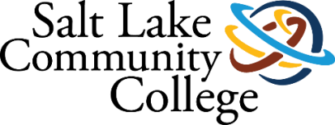 | OFFICE OF ADMISSIONS
2022-2023 ANNUAL ASSESSMENT
SUMMARY OF RESULTS

Project (Assessment) Title: Early Enrollment Admissions Process
College-wide Strategic Goal
Achieve Equity in Student Participation and Completion
Assessment Overview
In 2017 the Early Enrollment Process transitioned from the South Region to the Admissions Office and arrived with its own set of criteria and process. Since this transition, we have made significant changes to the application process with the new application portal and CRM (Customer Relationship Management). Additionally, in 2020 Admissions instituted a formal appeal process for students that did not meet the admission criteria. Although we have made significant changes to the application process, we have not made changes to the admissions criteria (11th grade, placement into Math 1010/1030 and English 1010, parent permission form and high school support letter). Beginning in Summer 2020, we launched a formal appeal process for students who do not meet the admissions criteria. Students fill out an appeal form indicating the reason(s) for the appeal which could include their grade level or low placement (in either English or math). With Admissions now offering a formal appeal process, we would like to assess how students that meet the admission criteria perform versus those that were granted an exception through the appeal process. We would also like to see the difference in the students that meet the criteria versus those that don’t to see if we are unintentionally excluding students from the program.
Methodology (Plan/Method)
We will be comparing students that met the admission criteria and those that were granted an exception to the admission criteria through the appeal process from summer 2020-summer 2023. We will assess how well the students performed in their courses, average credit load, what courses they took and if they continued at SLCC (Salt Lake Community College) post high school graduation.
If we don’t learn enough through quantitative data analysis, we will potentially provide qualitative data by surveying or conducting focus groups on students that have participated in the Early Enrollment Process to learn more about their experience.
We will use all assessment data to make recommendations on making the Early Enrollment Admission process more inclusive and equitable for all student groups.
Timeline
October-November: Meet with Data Science and Analytics Team to summarize assessment goal and come with a process.
December-March: Admissions and DSA (Data Science & Analytics) will pull data about students in the Early Enrollment Program from fall 2017-fall 2022 from the Data Warehouse, Banner, Etrieve and Salesforce.
March-April: Assess all data sets on admission applicants.
May-June: Final write up on the Early Enrollment program and make recommendations on potential changes we would make to the program.

Results/Finding (Disaggregated by race/ethnicity)
From summer 2020 to summer 2023, we had 964 students participate in the Early Enrollment program. Of these students that participated, 75% earned at least a 3.0 or higher in the courses that they completed. The following graphs show the participation disaggregated by First Generation Student status, race, ethnicity and gender.
The multicolor tables in the graph section below show the breakdowns by each semester and then filtered by the above demographic information. The table on the right shows the total GPA based on the filters for the various groups. We will first look at the GPAs for different demographic groups for all Early Enrollment Students, and then compare them to the GPAs for the students who did not meet the Early Enrollment requirements and were admitted by the appeal process.
EARLY ENROLLMENT STUDENTS THAT MET ADMISSIONS CRITERIA
Graph Key:
First Generation:
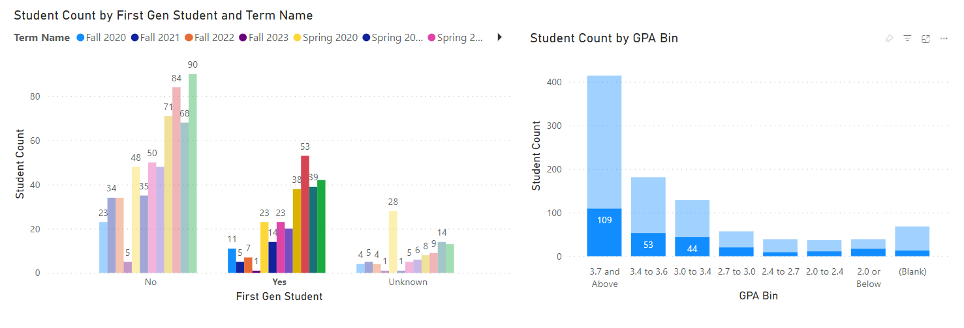75% of all Early Enrollment Students that identified as a First-Generation College Students earned a 3.0 or higher
Race:
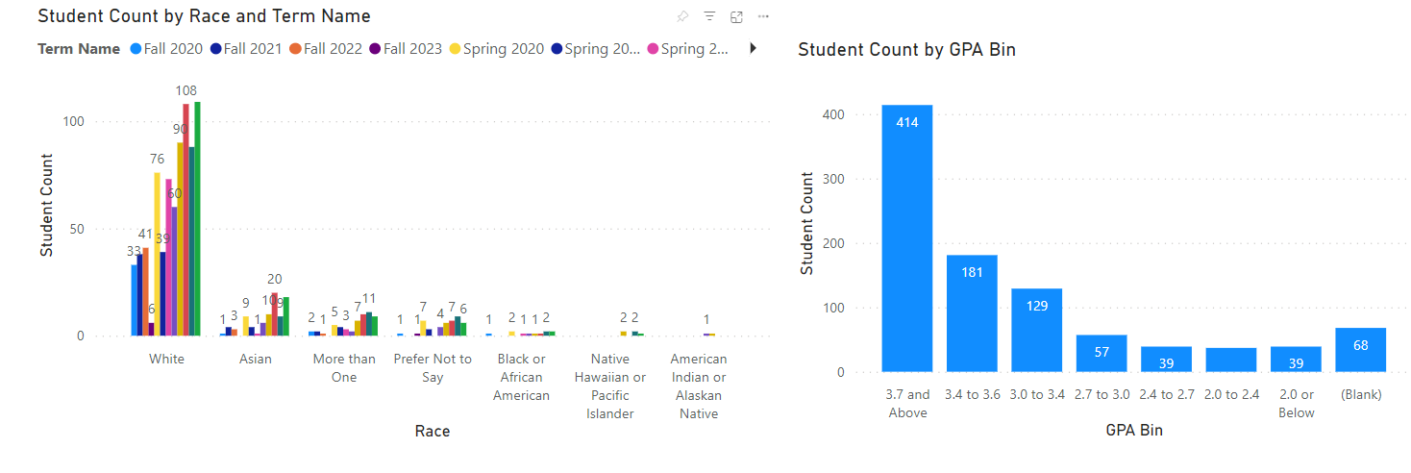Early Enrollment Students are predominantly white. (Note, Data Science and Analytics created a dashboard that we can filter by each race, however, due to the small sample size it is difficult to display the GPA graphs by individual race).

Ethnicity: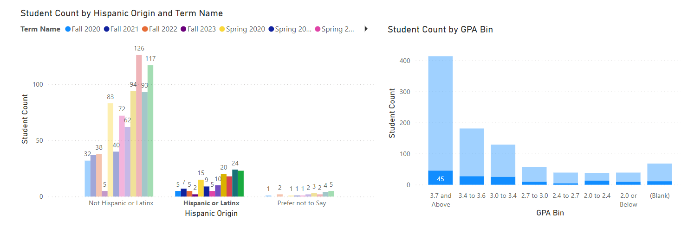68% of students that identified as Hispanic earned a 3.0 or higher for the courses they completed
Gender (female):
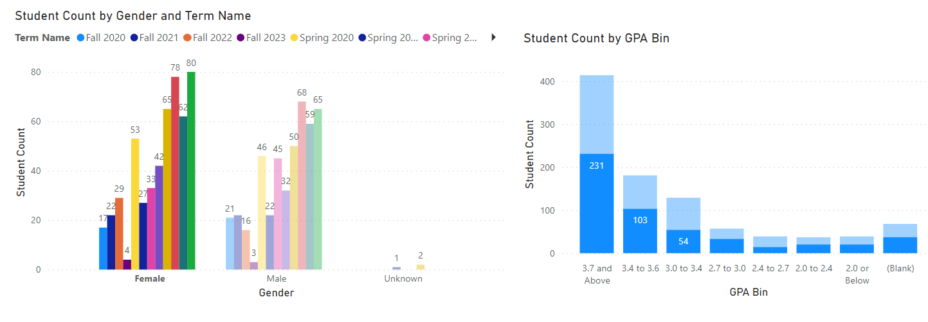75% of students that identified as female earned a 3.0 or higher for the courses they completed
Gender (male):
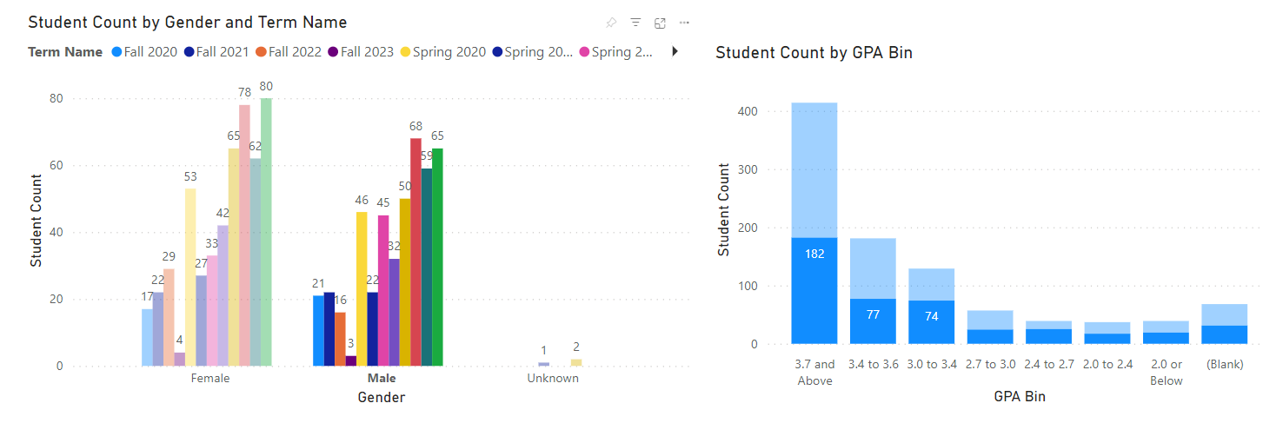74% of students that identified as male earned a 3.0 or higher for courses they completed
EARLY ENROLLMENT STUDENTS ADMITTED THROUGH FORMAL APPEAL PROCESS
Of the students that participated in Early Enrollment, 28 students (3%) were admitted to the program without meeting the Early Enrollment Admission Requirements. Of the students that did not meet the Early Enrollment Admission Requirements, 20 students (71%) earned at least a 3.0 or higher in the courses that they completed. Although this is a small sample size, the students that did not meet the admissions requirements performed comparatively to those that did meet the admission requirements.
Graph Key:
First Generation
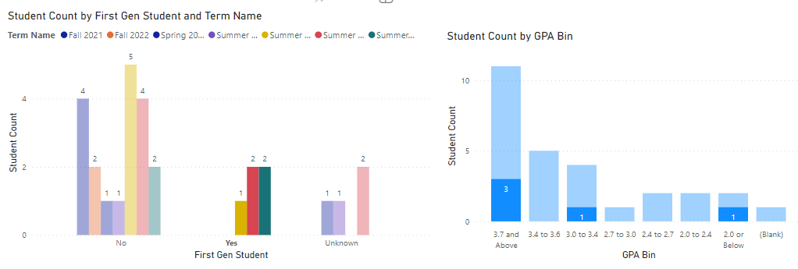80% of First-Generation College Students who appealed the admissions requirements earned a 3.0 or higher
Race:
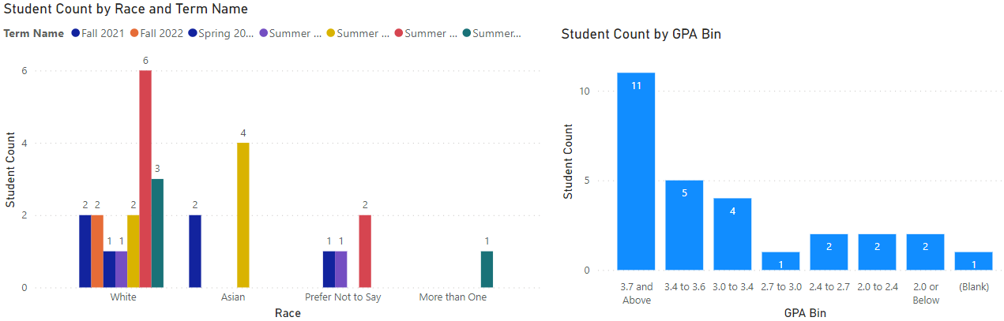Of the students that appealed, 83% of students of Asian descent earned a 3.0 or higher. (Note, Data Science and Analytics created a dashboard that we can filter by each race, however, due to the small sample size it is difficult to display the GPA graphs by race)

Ethnicity:
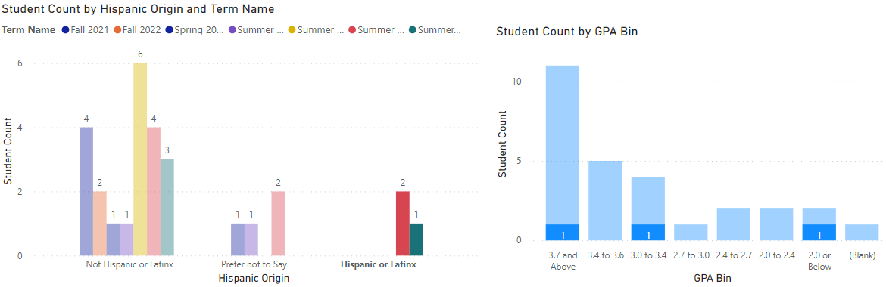66% of Hispanic Origin students who appealed earned a GPA of 3.0 or better
Gender (female):
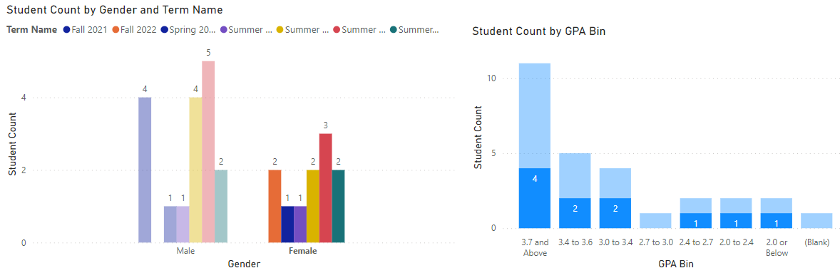72% of female students who appealed earned a GPA of 3.0 or better
Gender (male):
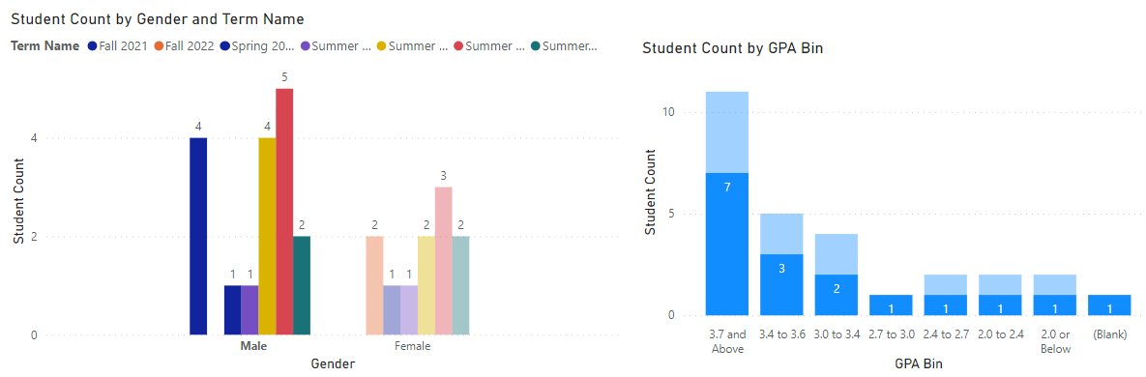75% of male students who appealed earned a GPA of 3.0 or better

Other Notes:
While working with DSA on the data for the assessment, we discovered another group of 43 students that were inadvertently admitted for Early Enrollment without meeting the admission requirements or submitting a formal appeal. Although we intended to make a side-by-side comparison of the two groups, this allowed us to expand our assessment and analyze the success of students in this third group. These students performed surprisingly well with 34 (79%) earning a GPA above 3.0 for the courses that they completed.
Graph Key:
First Generation:
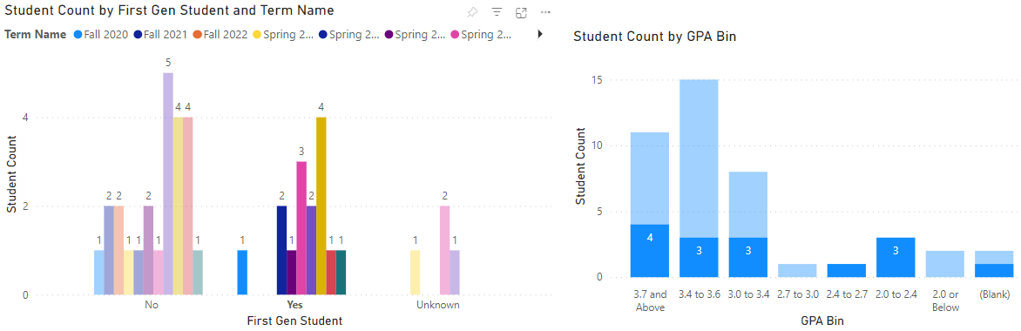71% of First-Generation College Students who did not meet the admissions requirements nor submit an appeal earned a 3.0 or higher
Race:
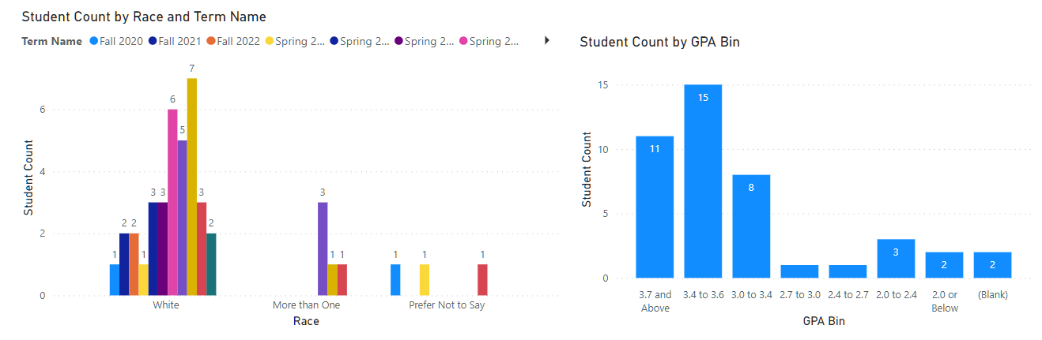We encountered a very small number of students that identified themselves as another race other than white that submitted an appeal.
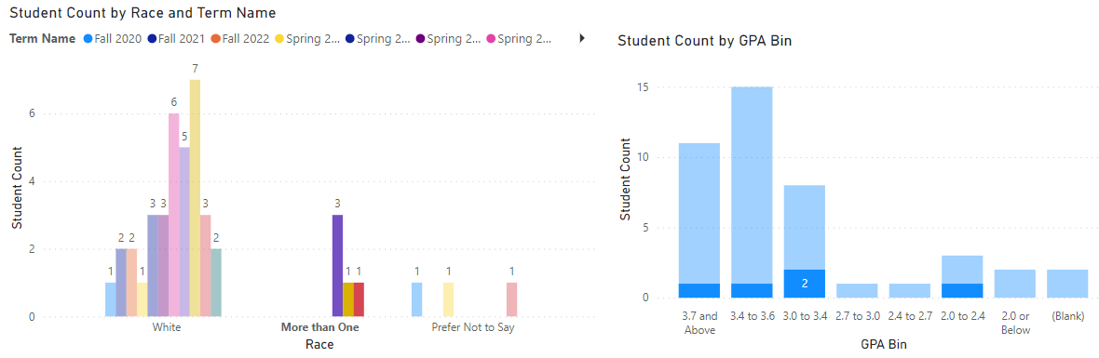Of the students that appealed, 80% of students that are more than one race earned a 3.0 or higher. (Note, Data Science and Analytics created a dashboard that we can filter by each race, however, due to the small sample size it is difficult to display the GPA graphs by race
Ethnicity: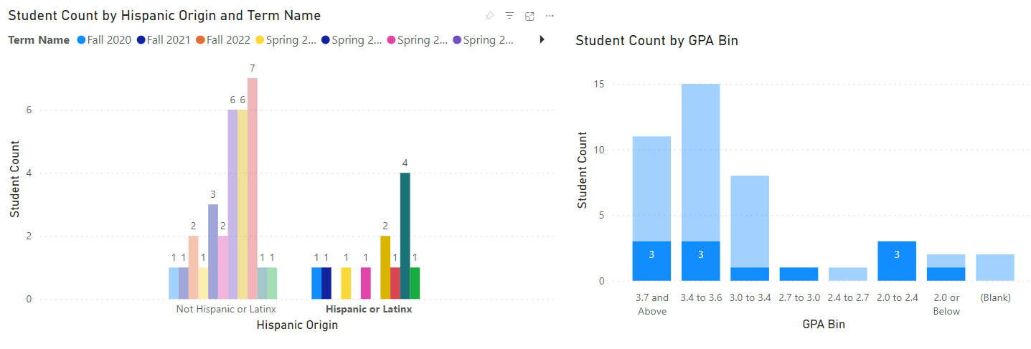58% of Hispanic Origin Students who did not meet the admissions requirements nor submit an appeal earned a 3.0 or higher
Gender (female):
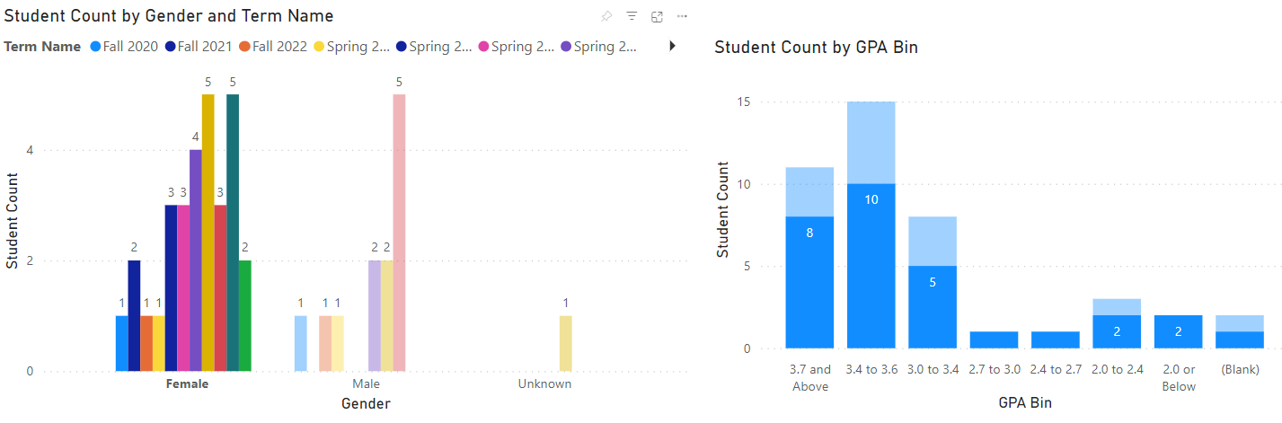77% of Female Students who did not meet the admissions requirements nor submit an appeal earned a 3.0 or higher

Gender (male):
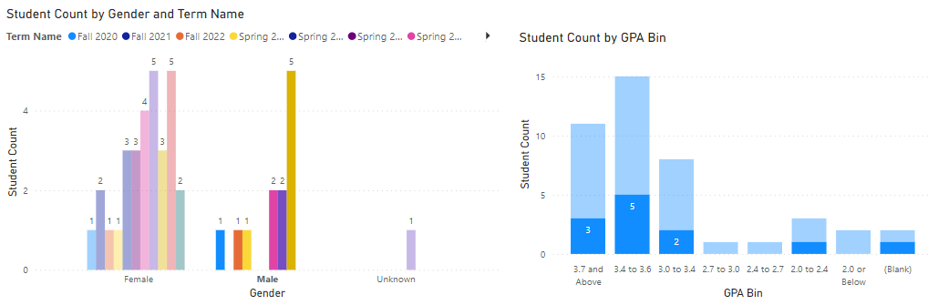83% of Male Students who did not meet the admissions requirements nor submit an appeal earned a 3.0 or higher
Action Plan (Use of Results/Improvements/Call to Action)
Although we were working with a small sample, after reviewing the data sets, we see that Early Enrollment Admissions Requirements did not have a measurable impact on student success.
As mentioned above, the appeal process is in its third year of implementation. We were hoping to remove some of the parameters that act as a barrier to admission, however, we don’t feel confident that we have enough data to make an educated decision on the admission parameters. We will continue to monitor the program and the appeal process to see if the trend continues with a larger sample size and reassess it at a later date. If this trend continues, we will form a campus wide committee to make recommendations on policy changes.
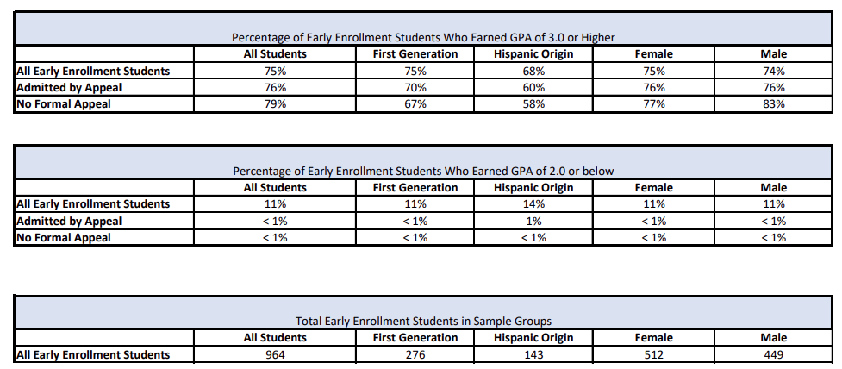
Another concern is regarding the participation of marginalized communities in the Early Enrollment program. One of SLCC’s Goals is to have our student population match the demographics of the county. Currently, the Early Enrollment program is far from mirroring the population of Salt Lake County. One of the biggest barriers for marginalized communities is the lack of financial support. Currently, Early Enrollment students are required to pay full tuition and student body fees and are ineligible for Federal Financial Aid and scholarships. Ideally, we would like to see some form of financial support become available for these students either through donor support or scholarship policies adjusted.
Lastly, we are concerned with high school students' knowledge and awareness of the Early Enrollment program. We know high school students heavily rely on their high school counselor for information on opportunities available to them. We will be hosting our annual High School Counselor and Community Partners Conference in October of 2023. At this conference we will be dedicating one of our breakout sessions to educating our high school counselors on the opportunities available to their students and encouraging them to share this with parents and students from their high school.

