SLCC High School
4600 S Redwood Rd
Salt Lake City, UT 84123
Ph: 801-555-5555
Fx: 801-555-5567

Official High School Transcript Disclaimer

Prepared for: Salt Lake Community College
Date: 10/22/2019

This transcript is official when received with an attached and signed disclaimer letter emailed directly from the SLCC school district.

Best Regards,

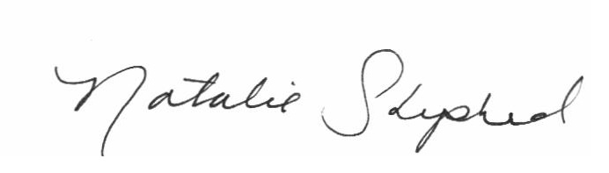
Natalie Shepherd
SLCC High School Registrar

