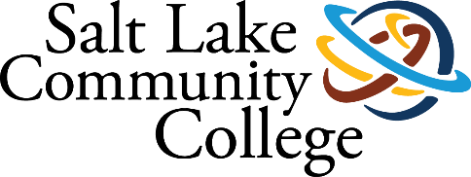 | Academic Advising
2021-2022 ANNUAL ASSESSMENT
SUMMARY OF RESULTS

Project Title: Advisor Dashboards for Case Management

College-wide Strategic Goal
This assessment plan supports the college’s first strategic goal of increasing student completion using strategy two of scaling student analytics.

Assessment Overview
One of the difficulties we’ve experienced in Academic Advising for Case Management is it is difficult for advisors to see and impact on their caseloads. MySuccess can help us see who is in a caseload, track early alert flags, but does not currently have a way to view their individual scores on student satisfaction and learning outcome surveys or the graduation and meeting rates of students in their caseloads. The purpose of this project is for the advisors to have more information about their student outcomes to create personal goals. In addition, the dashboard will enable advisors to do outreach for students that have holds that prevent them from registering or receiving financial aid instead of having to look up individual students like we currently do.

Methodology
The director worked with Data, Science, and Analytics to get the initial concept for the dashboard drawn out and created. Adjustments had to be made depending on what data was readily available to pull into the frame and what needed more research.
While we were able to get a usable version of the dashboard to help assist with student issues, we found the following difficulties in creating the intended functionality:
- We do not have an automated way of grouping programs of study into areas of study
- We do not have data points in Banner that quickly identify students who need to complete a financial aid appeal to receive funding
- DegreeWorks percentages work for most but not all programs
- School of Applied Technology student retention tracking requires different tracking, none of which is found in Banner or other DSA dashboards.

Plan to Disaggregate Data by Race/Ethnicity
Advisors are currently able to pull students by race or ethnicity for outreach. Each of the insights metrics also has a function to show retention data by multiple demographics.

Timeline
The initial launch of the advisor dashboards occurred on June 9, 2022 in which advisors received training on how to use the dashboards for creating lists of students for proactive advising campaigns.

Results/Finding
The advising dashboard is live at https://data.slcc.edu/advising. Advisors are currently testing it for usability and improvements.

Action Plan
The advising dashboard is an ongoing project as advisors test the different features and the college creates a new strategic plan. In the near future, the next set of metrics we will be adding to the dashboard are the daily and annual survey responses so advisors can have access to individual feedback for their professional goals.
Advising Dashboard Productivity Metrics-Proposed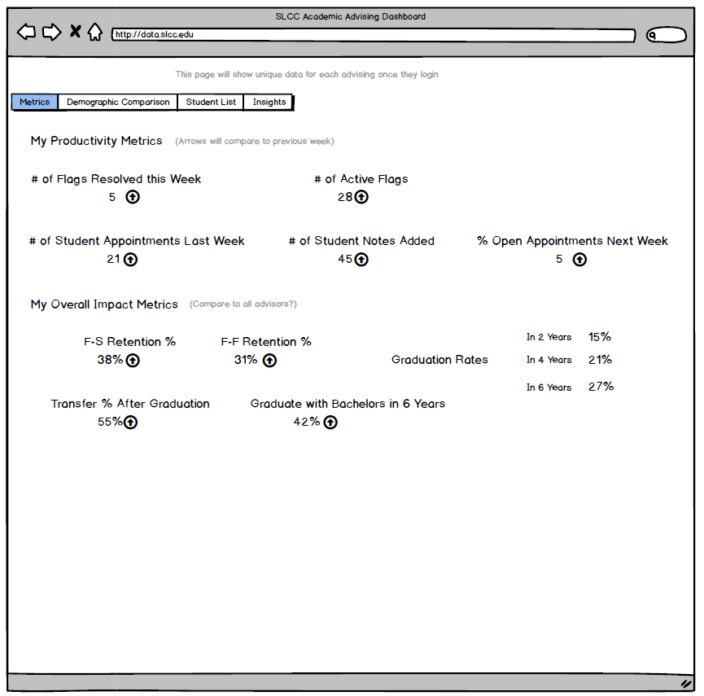
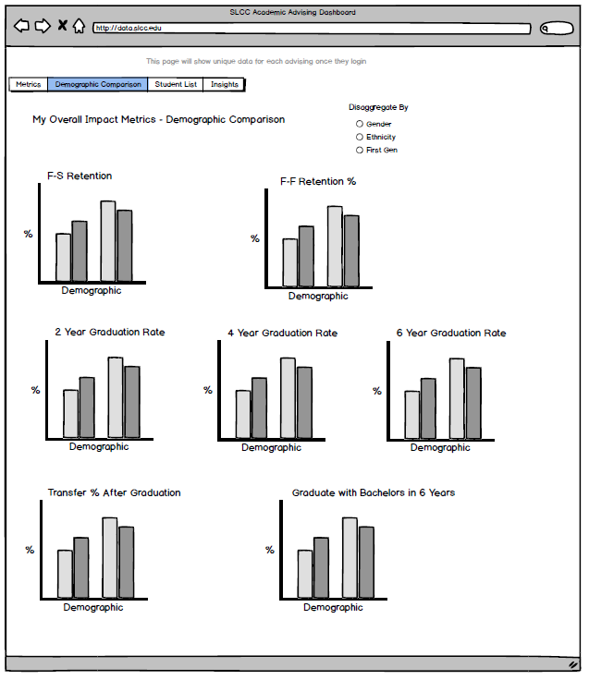

Advising Dashboard Productivity Metrics-Actual
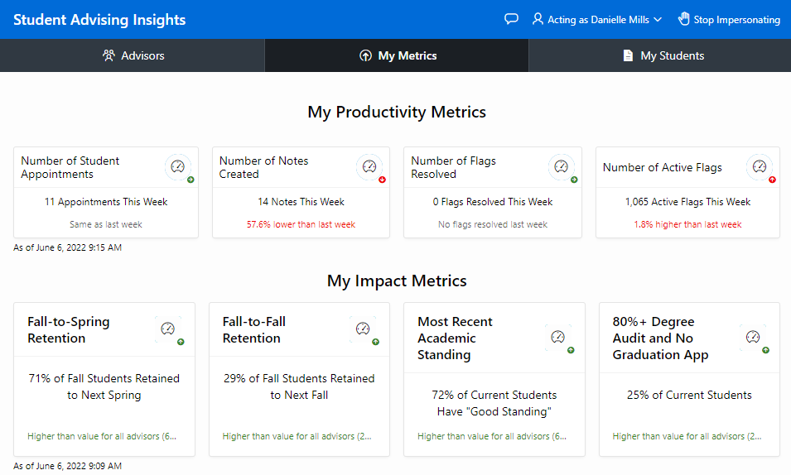

Demographic breakdown example

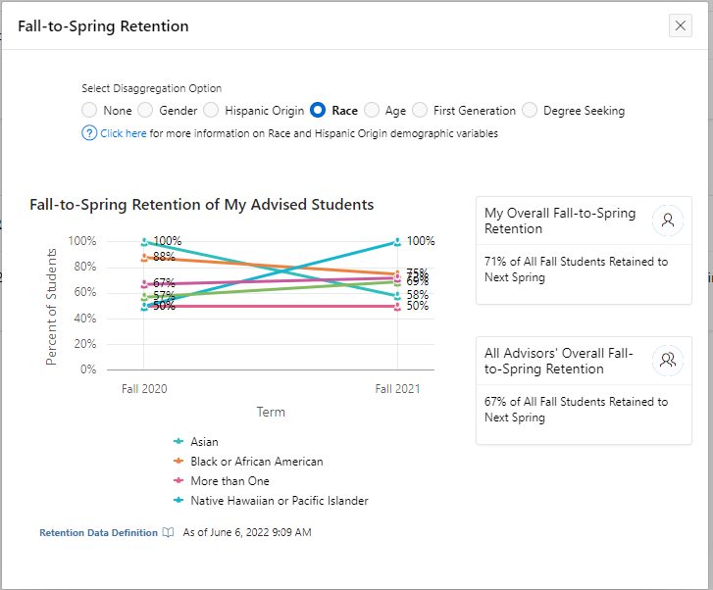
Advising Dashboard Caseload Filters-Proposed 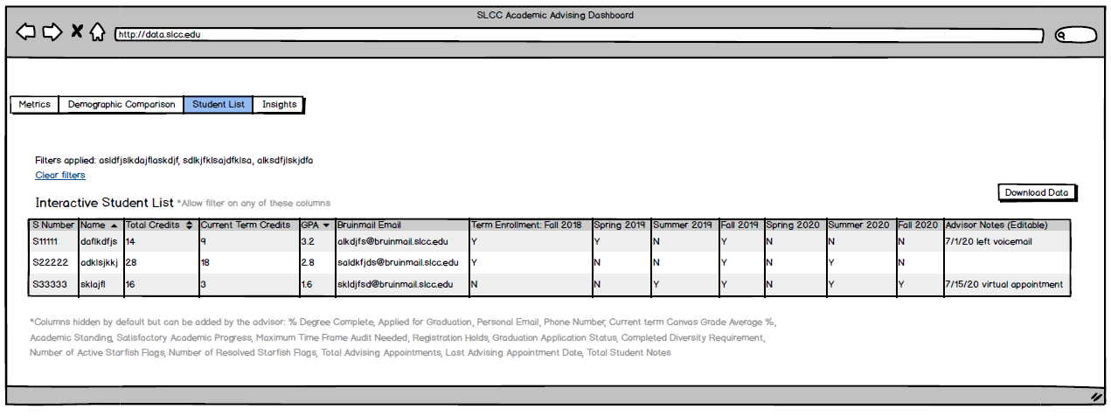

Advising Dashboard Caseload Filters-Actual 