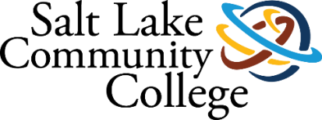 | Admissions and  Campus & Site Services, South Region
2021-2022 ANNUAL ASSESSMENT

SUMMARY OF RESULTS

Project (Assessment) Title
Herriman Future Student Expectations/Herriman Campus Footprint Planning

College-wide Strategic Goal
Achieve Equity in Student Participation and Completion
Increase Student Completion
Increase College Participation

Assessment Overview
Working with our community and high school partners to gather data on what students expect in their student experience for the Juniper Campus at Herriman.

Methodology (Plan/Method)
1- Work with Data Science and Analytics to review city demographics.
2- Work with Herriman, Mountain Ridge and Providence Hall high schools to learn more about their student body demographics. Conduct a survey to the high school students to learn more about what they want their college experience to be.
3-Work with high school administration, counselors, Concurrent Enrollment coordinators and CTE coordinators to learn more about the needs and wants of their student body.
4- Use High School Feeder Reports to further understand the incoming student demographics for the region.
5- Analyze data to identify student wants and needs and build services around those expectations.

Timeline
October: Meet with DSA to get city demographics that are readily available. Work with DSA to develop the survey for Herriman, Mountain Ridge and Providence Hall high schools.
November: Meet with Herriman, Mountain Ridge and Providence Hall to discuss dissemination plans of the survey to high school students, administrators, counselors, Concurrent Enrollment coordinators and CTE coordinators.
December/January: Disseminate and collect survey results
February/March: Assess survey results
April-June: Report Findings

Results/Finding (Disaggregated by race/ethnicity)

Census Data
Data from the 2020 Census show very similar demographics in the 84065, 84095 and 84096 zip codes. Compared to Salt Lake County, these populations are less Hispanic & Latinx, less racially diverse, households have higher income and education levels, and fewer households speak a language other than English. Details from each zip code are illustrated in Appendix A.
Prior to the focus group, the principal and assistant principle shared with us that they have experienced a lot of growth at their schools from the Latinx community due to refugees and asylum seekers, primarily from Venezuela. This growth is recent and is not reflected in the Census Data.

High School Feeder Reports
The feeder reports for Herriman and Mountain Ridge High School provide a snapshot regarding student readiness, performance, and persistence in the first year of college. The report is an evaluation of the first non-concurrent Fall semester of students less than 20 years old at time of attendance. High School Feeder reports are in Appendix B.

Student Focus Groups
Three focus groups were conducted at Herriman High School with a total of 51 participants. Diego Pliego Nava, Qualitative Research Analyst from Data Science & Analytics led the discussions, and Kate Broderick and Shannon McWilliams observed and took notes. The summary of results is in Appendix C.

Action Plan (Use of Results/Improvements/Call to Action)
- Share focus group and census data with Student Affairs leadership and the Herriman Planning Team to assist in strategic and operational plans for the new campus.
- In conjunction with the University of Utah, host a high school counselor luncheon at the Juniper Campus for counselors in the southwest quadrant of Salt Lake County.
- Add information about the Juniper Campus to SLCC marketing materials such as the campus view book, and ‘Getting Started’ packet with outreach specific to 2023 high school graduates.
- Have as many bilingual staff and faculty as possible available at the Juniper Campus to support the growing number of refugees and asylum seekers in the community.

Other Notes
In September 2021 we explored two survey options but determined they were not viable: A) High School Student Survey—this would have required parental permission, even for those enrolled in SLCC Concurrent Enrollment classes, and we considered this an unreasonable request of the high school administration; and B) Herriman Community At-Large Survey—we met with a consultant from Qualtrix to complete an initial assessment of our survey needs. Their team met and determined that in order to get a response from at least 200 residents the survey range would have to be expanded by 30 miles resulting in too many responses outside the community surrounding Juniper Campus. Therefore, we revised our plan and conducted three in-person focus groups at Herriman High School.

APPENDIX A: 2020 Census Data

Zip Code 84065: Bluffdale, Riverton, Herriman, South Jordan
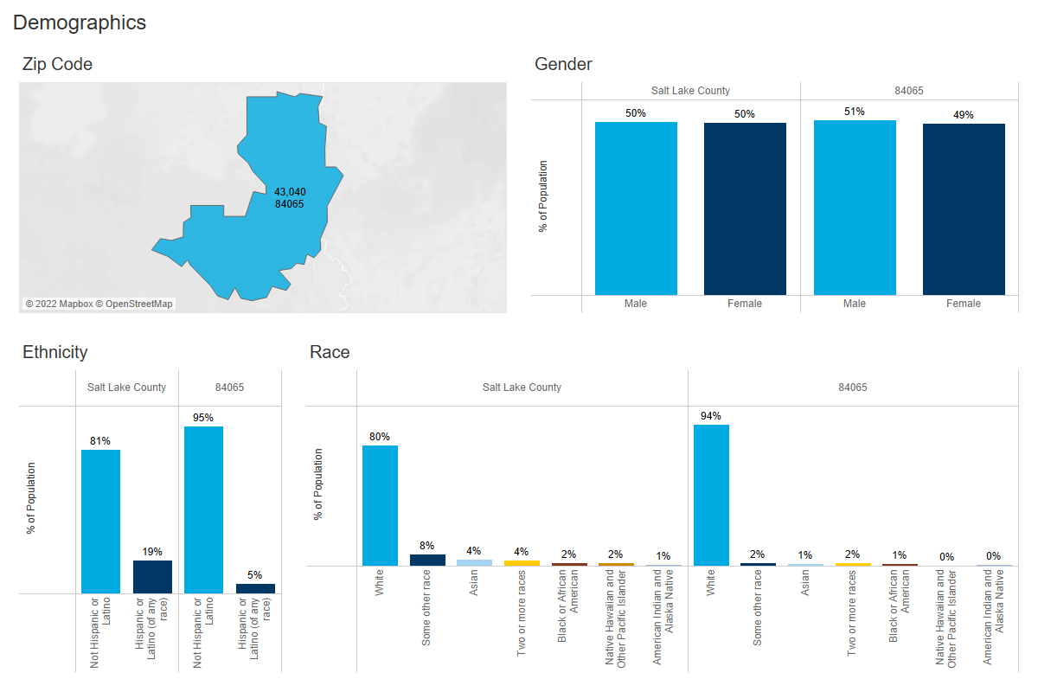
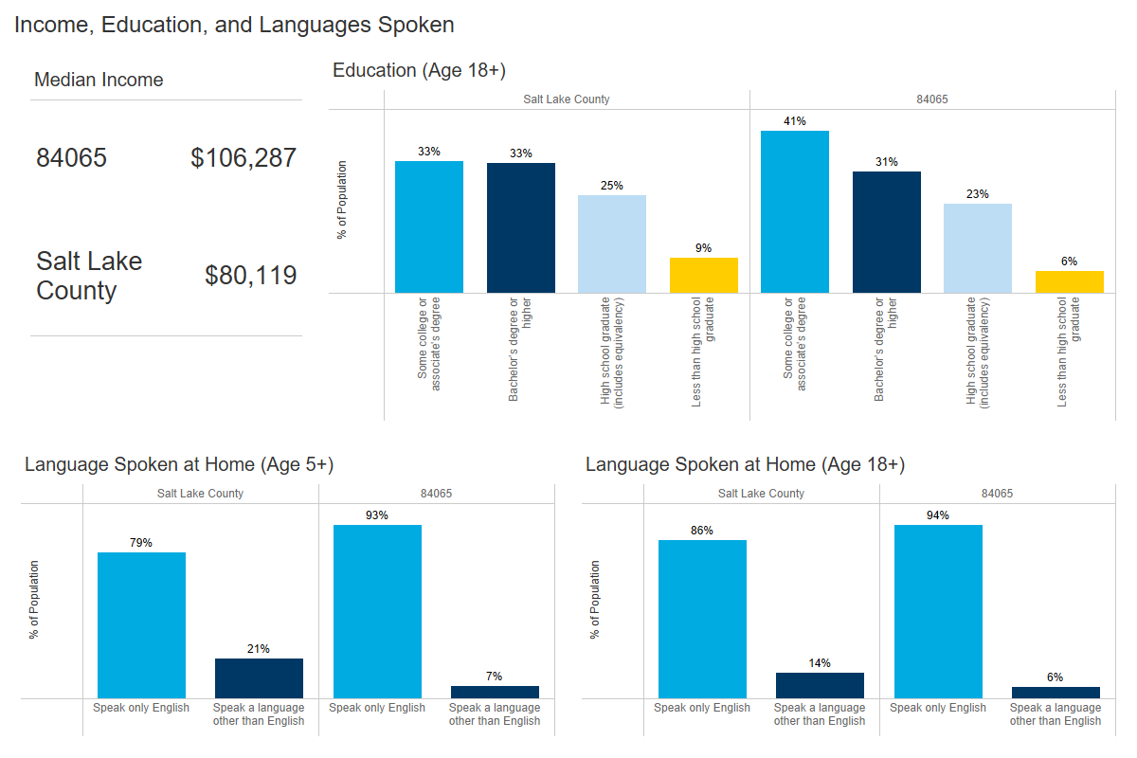

Zip Code 84095: Riverton and South Jordan
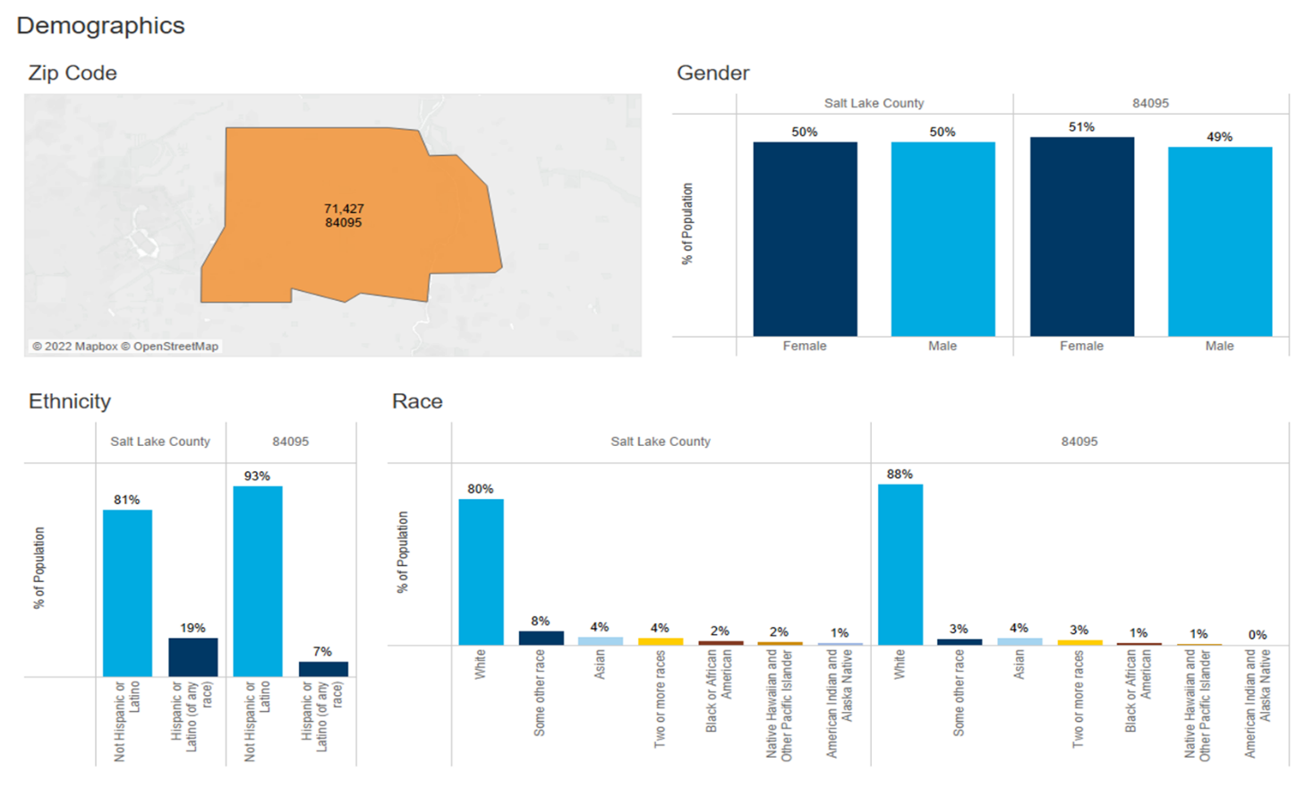
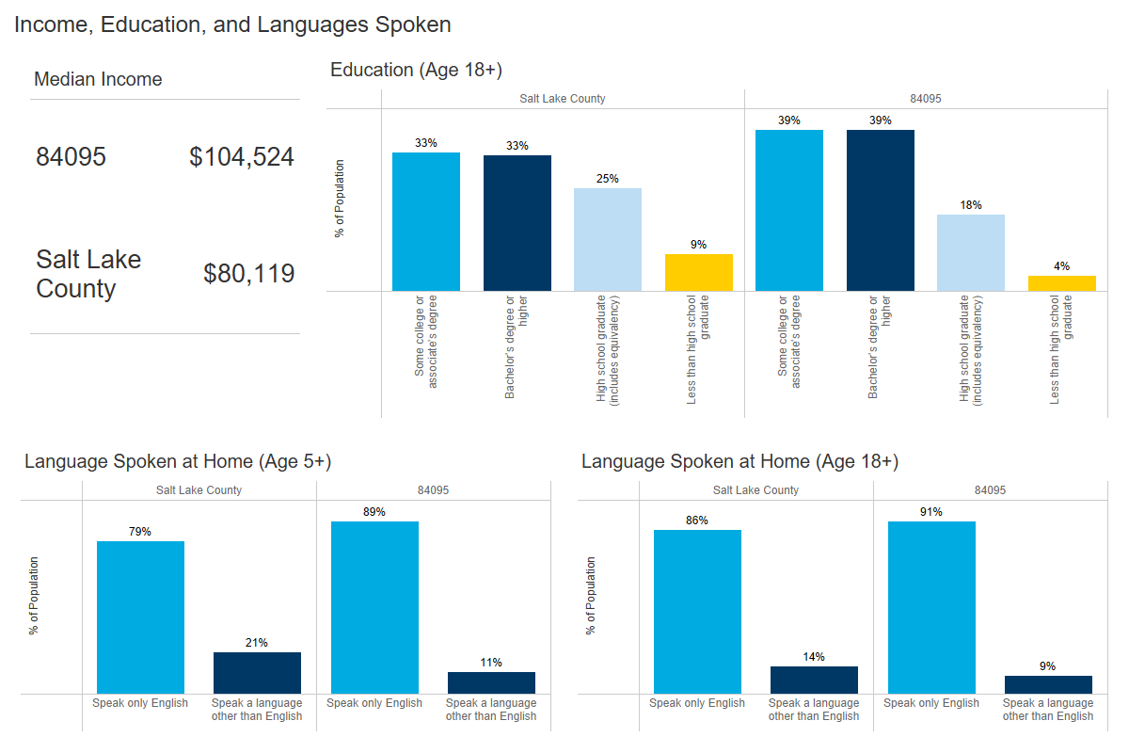

Zip Code 84096: Riverton
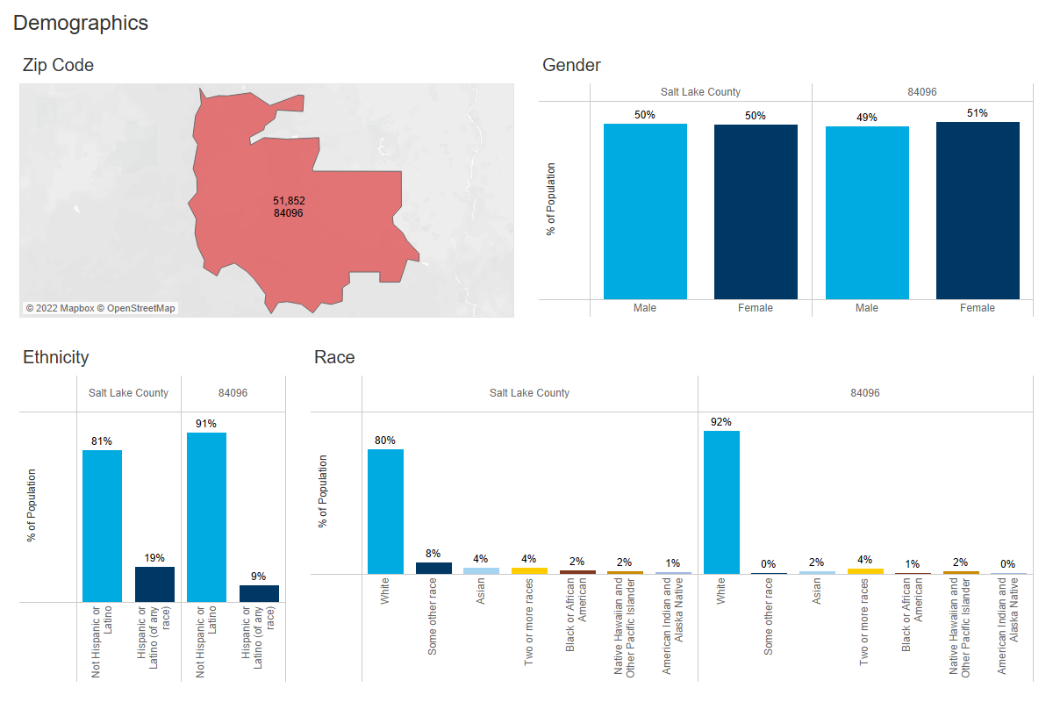
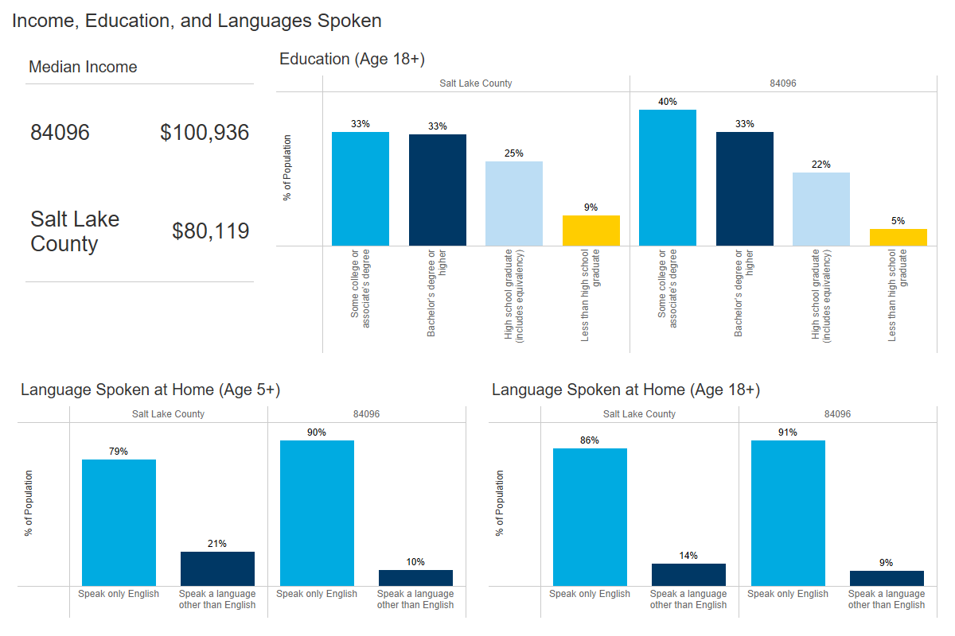

APPENDIX B: Herriman and Mountain Ridge High School Feeder Reports

APPENDIX C: Focus Group Executive Summary

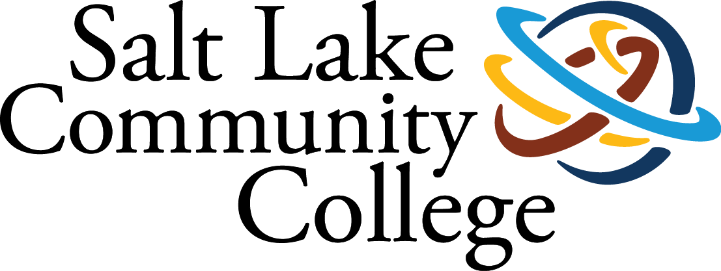

Diego Pliego | June 2022

Lara Pantlin | July 2019

DATA SCIENCE & ANALYTICS

South Region Assessment Focus Group Summary
summary of Results

Summary: South Region Assessment Focus Group Summary

Background & Methodology
Salt Lake Community College is in the process of constructing a new campus meant to serve students in and around the Herriman community. As part of the process of opening this new campus, researchers set out to understand what the expectations of potential incoming students are regarding their college experience. Researchers partnered with Herriman High School to conduct in-person focus groups with seniors from the school. Three 30-minute focus groups were conducted with a total of 32 students that participated.
Findings
Student responses were organized based on different expectations they had in multiple areas:
- Academic
- Clubs & Organizations
- Social
- Services and Resources
- Physical Space

Caveats & Recommendations
- Provide opportunities to educate and advise current and future students on the courses, organizations, and resources offered at SLCC
- Increase visibility of activities and services through advertising across different spaces, such as online social media platforms
- Collect student input and use it to plan activities and services that will be provided to students
- Find ways to foster positive relationships between students and faculty/staff

Full Report: South Region Assessment Focus Group Summary

Introduction
Salt Lake Community College (SLCC) is in the process of constructing a new campus meant to serve students in and around the Herriman community. This campus is set to open Fall 2023 and will house several different paths of study and provide a partnership with the University of Utah that will ease the transition to a four-year institution after graduation. As part of the process of opening this new campus, researchers set out to understand what the expectations of potential incoming students are regarding their college experience. Researchers partnered with Herriman High School to conduct in-person focus groups with seniors from the school. Three 30-minute focus groups were conducted with a total of 32 students that participated. These focus groups were recorded, transcribed, and excerpts of student responses were thematically coded and analyzed.

Results
Students were asked a series of questions that focused on three areas: academics, social experiences, and physical space. Student responses were then organized based on different expectations they had in multiple areas: academics, clubs, services and resources, social, and physical spaces. These expectations, which were shaped by student experiences, serve as a guide to what students hope to see in their institutions of higher education:
- Academic
- Clubs & Organizations
- Social
- Services and Resources
- Physical Space

Academic Expectations
- Factors that influenced students’ academic expectations included:
  - Their relationships with faculty and staff
  - The academic courses that were available to them
  - The workload of the courses they take
  - Study habits

Among the academic expectations that students had, many of them prioritized the relationships that they were able to have with faculty and staff. Students appreciated being able to communicate openly about personal and academic topics with faculty and staff and often referred to their ability to engage with faculty and staff as a factor for their success. Along with the relationships they had with faculty and staff, students discussed the importance of knowing what courses are available to them. One student stated, “I would say [schools should] display fully like the specific education and courses that way people know exactly what they’re getting.”

Along with having a knowledge of what is available to them, students expressed frustrations of not knowing what to expect from courses and the workload associated. One student shared their frustration saying, “I feel like a lot of teachers do busywork and it’s not very educational and it honestly makes me hate the class... I feel like if they just have all that fodder it just kind of ruins it and makes you not want to participate in the class because you’re like ‘well, why am I doing this?’”

Clubs and Organizations Expectations
- Factors that influenced their expectations for clubs and organizations included:
  - How clubs connect to students’ areas of study
  - Support they receive from schools and institutions
  - The relevance they have to students and communities
  - The visibility and accessibility of different clubs

When discussing their expectations of clubs and organizations, it was imperative that they be relevant to the lived experiences of the students that participated. For some, this was defined by how the club or organization related to their social experiences or to how it related to the community the student was in. Several students referred to activities that were hosted by clubs and organizations at SLCC, such as the Pow Wow or GSSRC-sponsored events, as being important for them and their communities.

It was also very important for students to have access to clubs and organizations that were connected to their areas of study because they provided students with opportunities to connect with others in similar fields and gain experience relevant to their majors. One student said, “I’d like to see clubs that are focused on like certain majors like a pre-dental club or something... so you can just surround yourself with people that have similar interests and so you can connect and make a network.”

Even though there are clubs and organizations that would meet student needs, participants brought up how students often are not aware of their existence. One student noted, “I’ve been to [SLCC] campuses and one of the things I’ve noticed while going through the halls is that [the college] doesn’t promote clubs as much as at our high school. And so, I think that something that could be a little bit more beneficial is constantly promoting those type of clubs that you want your students to kind of participate in so that they’re aware that those are actually happening.”

Social Expectations
- Factors that influenced social expectations included:
  - The level of inclusion
  - How engaged and involved the student body is as a whole
  - Student wellbeing

The social expectations students discussed centered on the importance of having spaces where they felt included and their wellbeing was emphasized. When talking about inclusion one student said, “I think that it would be really cool to include the community around Herriman and in this area and have them kind of learn more about different cultures and also like be able to participate in gatherings and social projects [SLCC] is working on.” Several students shared similar perspectives regarding inclusion of students and their communities throughout the college.

Students also mentioned the importance of having an active student body that they felt a part of and why that was important to them. One student stated, “The more that we do in our school and the more we’re helping out other [students], it unites us as a student body, like everyone is getting along and we’re having fun. We’re all doing events; we’re all cheering on for each other and it just feels more united and like we belong.”

Services and Resources expectations
- Factors that influence expectations of services and resources included:
  - Academic support services
  - Student advising
  - Language services

The services and resources that students talked about reflected the shifting demographics around Herriman. Several students talked about the importance of providing language services, including translation services, interpreters, and different resources in many different languages, to students throughout the institution. Even though almost all the students presumably spoke English as their first language, they recognized how providing linguistically diverse services creates a welcoming and inclusive space for diverse students. Several students pointed out that there has been an influx of Spanish-speaking students from many countries in their community over the last few years, and that they have witnessed how language can be a barrier for their peers. As one student put it, “Something else to go along with what [the other students] were saying, having professional translators or interpreters on staff that are accessible to the students would be like a big help. And if teachers can have a better personal connection with [English language learning students] and maybe spend more time and... help the students who might be struggling a little bit more because of language barriers.”

Along with language services, several students talked about the need for student advising and outreach so that students could better understand what is offered by the institution they are attending.

Physical Space Expectations
- Factor influencing expectations of physical spaces
  - How physical spaces impact student experiences

When it came to the expectations of the physical spaces that students interact with, students talked about how those physical spaces needed to support their social and academic lives. For some, this meant having dedicated study spaces for individuals and study groups that had all the resources that students needed, such as whiteboards, sitting areas, quiet spaces, Wi-Fi, visual aids, and course-specific resources they could use. For others, there needed to be spaces that allowed for and encouraged students to interact with each other, such as having common areas or different types of eating areas where they could interact with other students.

Recommendations
Based on student responses and expectations, SLCC should keep several things in mind as we continue to work in the community surrounding Herriman. Across all the focus groups that were conducted, students shared how they did not know what courses, organizations, and resources were offered at SLCC. It is important that the college provides opportunities to educate students about what the college offers and to advise them on how that may impact their academic future. These advising and education opportunities should be available to current and future SLCC students.

Another aspect to consider is how visible different opportunities and services are across the college. Many students expressed how even though an institution might provide many different opportunities and services that meet their needs, if they are not aware of those services then they are not going to interact with them. Advertising across multiple platforms, such as online social media platforms, could provide students some insight into what is going on across the college.

Another thing to keep in mind is to collect student input whenever planning what services, clubs, and opportunities will be offered. Students talked about how important it was for their voices to be heard and used in the decision-making process.

The final consideration is to find ways to actively connect students with faculty and staff in ways that foster positive relationships between both groups. Connecting with instructors was something that every focus group discussed and is something that SLCC must consider as we seek to improve the student experience across the college.

