|  |  |
| --- | --- |
| SLCC Logo | **VETERANS SERVICES** |
| 2021-2022 ANNUAL ASSESSMENT SUMMARY OF RESULTS |

**Project (Assessment) Title:**

**Texting Campaign/Costs (Signal Vine)**

**College-wide Strategic Goal:**

1. **Retention: Increase student semester completion up through graduation**
2. **Equity: Achieve equity for on-time GI Bill educational funding (Tuition – Housing – Book Stipend) for all student veterans through clear and resourceful communication so all students may obtain their GI Bill educational benefits promptly and accurately each semester**

**Assessment Overview**

**The texting campaign assessment is to research Salt Lake Community College’s texting program ‘Signal-Vine’. Research would include:**

* **Contract cost: Investigate Group and Individual texting**
* **Texting Platforms: two-way texting -vs- one-way texting (to students); unlimited texting**
* **Text response rate/time comparative to BruinMail and MySuccess response rate/time**
* **Reliably engage and immediately interact with student veterans through texting when an issue with GI Bill funding or course work that could delay funding of tuition and housing payments**
* **Texting the student veteran would almost guarantee a quick response to correct the issue to assure each student their GI Bill educational benefits are being promptly processed**
* **Compare GI Bill tuition/housing delays and payment time-frames relative to texting response time and BruinMail/MySuccess response time**

**Methodology (Plan/Method)**

**Alert student veterans immediately through text the below flagged indicator:**

**Immediately communicate (Flagged through MySuccess):**

**Credit Hour Discrepancy**

**No Pay Class (not within major or have previously taken)**

**Residency**

**Transcripts**

**Certification (Permission from student to process VA benefits - each semester)**

**Orientation Not Completed**

**Repeat Class (No Pay Class)**

**Academic Probation (AP)**

**Majors do not match with the VA**

**Information Needed**

**The above listed flags are a cause for GI Bill funding delays. When student veterans are notified through e-mail (BruinMail), the open rate is 16%. This low open rate causes an 84% increase in VA funding/tuition delays to Salt Lake Community College and housing payments to the student.**

**Methodology Cont.**

**No two students’ communication levels are alike. Many students use different types of communication tools creating a break/lag on return responses during their college experience. Some students demand/need more support than other students.**

**In the last 3 months, 285 new student veterans applied with Salt Lake Community College. 81% of those applicants have opted ‘in’ to accept texts. Quick and reliable communication through texting students on an individual basis can create positive tuition/housing on-time payments for Salt Lake Community College and student veterans.**

**Timeline:**

**Texting was to begin when Signal Vine costs were obtained. Costs were obtained and outlined on May 4th, 2022, and a final overview on May 9th, 2022. Below is an overview of the costs/contract payment:**

* **Departments would pay per contact**
* **Example: 15,000 contacts will amount to an annual cost of $28,500.00**
* **Veterans do not have that many contacts (cost would be a little lower)**
* **Semester Example: 400 veteran students – 2 texts each per semester = 800 texts = $1600.00 per semester**
* **$4500 - $6000 per school/calendar year for texting is counter productive**
* **Many times, there are more than 400 student veterans**
* **Several student veterans would require more than 2 texts per semester**
* **Texting program as it currently stands would be cost prohibitive**
* **The Contact Center is piloting a new texting platform called ‘RingCentral’ and should be more cost effective. Veterans Services will be advised when more information is obtained. No information as of the submission of this assessment.**
* **New Timeline: When a new and lower cost texting program is presented as stated with RingCentral.**

**Below are the Signal Vines current contract texting rates:**

**Signal Vine Contract Table:**

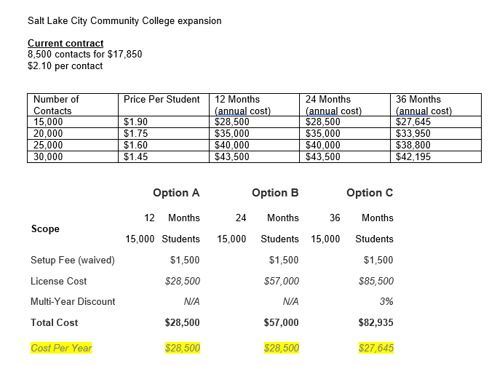

**Action Plan:**

**Below are response times to each MySuccess Flag sent to student veterans: (Outlined above under Methodology)**

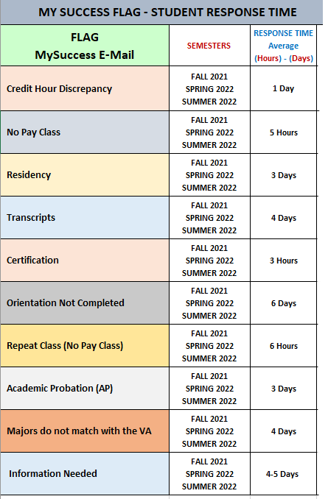

* **VA Funding/Tuition/Housing can be delayed up to 2 weeks or more if the student doesn’t respond to their MySuccess Flag / e-mail. A reply of 4 hours later can create a delay of benefits up to 1 week**
* **Veterans Services is regularly working to lower response times. When students have not responded within 24 hours, our staff reaches out via phone to advise them of their MySuccess Flag and assist during the phone call. There is a lot of phone call and e-mail fatigue amongst students.**
* **Approximately 91% of outbound calls to student do not answer the phone**
* **Texting students directly regarding their MySuccess Flag will greatly decrease tuition/housing delays for the school and student. Students usually do not read their e-mails on their phone.**

**Results/Findings**

**Once texting is an option, results and findings will be tracked, accumulated, and reported.**

**Other Notes:**

**Veterans Services assessment had an immediate approach/design change in the middle of May 2022. When the texting costs were presented, the costs were not conducive and could not be justified. This assessment outlines how texting can possibly expedite student communication, school tuition payments and student housing. Once the program is set up, this assessment will continue collecting data as indicated above.**