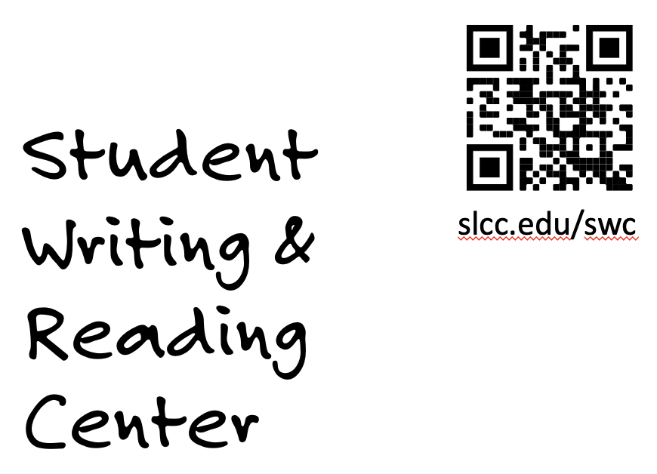Writing Across the College Logo
Website: slcc.edu/wac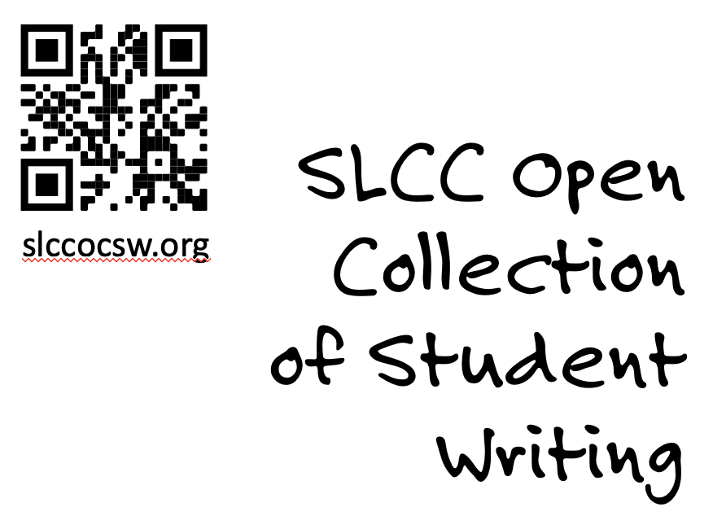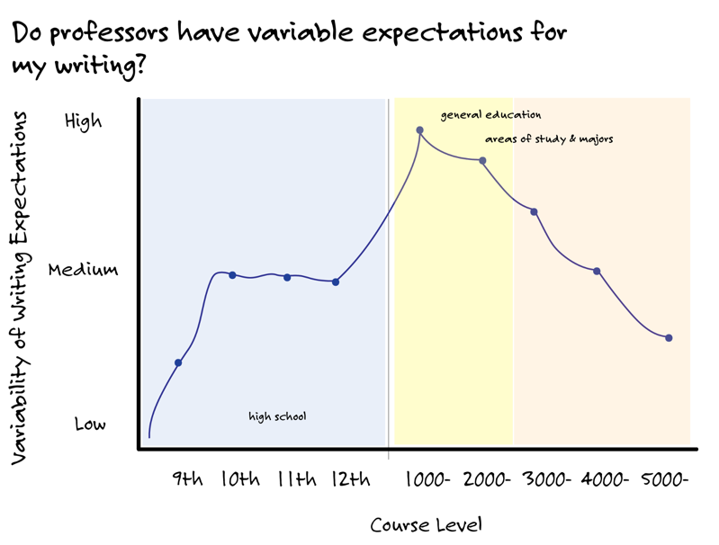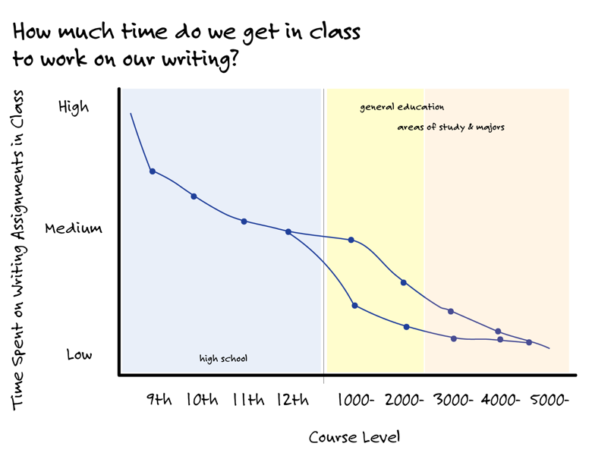

# Writing in College

**Links to Episodes**

#1: [How different is it from writing in high school?](https://youtu.be/HW8Ibj553Sw)

#2: [What do professors expect from me?](https://youtu.be/IQt45IiP6ws)

#3: [What questions should I ask? OR “How to read an assignment”](https://youtu.be/9lqR4zO0fiM)

#4: [How do I get support when I want it?](https://youtu.be/DW8YDeD3iEM)

## Writing Assignments: What Students and Faculty Should Expect

Everyone should expect that different readers often have different interpretations of the same piece of writing.

### Faculty need to:

* Give students a written assignment
* Provide evaluative criteria/rubric
* Tell students about writing support services.
* Answer questions about assignment
* Grade according to stated criteria

### Students need to:

* Take assignments seriously
* Read assignments closely
* Ask questions
* Ask questions
* Ask questions

## Read for What to Ask, if not found…

* Purpose: “What do you expect students to learn from doing this assignment? What should we focus on?
* Audience: “Who is our audience? Who should we be thinking of when doing this assignment?”
* Product: What type of document/product should we be working towards? Can you give it a name to help us understand it?”
* Process: “What steps should we take to make sure we do the assignment well?”
* Criteria/Grades: “What criteria will we be graded on? Does the assignment have a rubric?”
* (Examples): “Do you have any examples of assignments that you thought were done well?”