Applying and Updating Admission Application for APPEL Students

- Go to slcc.edu and click Apply Now, then Yes! I want to apply now.
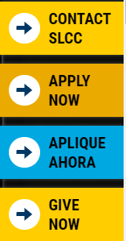
- If you are applying to the college as a new student, fill out the Registration Information.
If you have applied to the school in the last 3 years, click Back to Login.

The login credentials will be your personal email and your own password. If you don’t remember your password then click Forgot Password.


- Welcome to the application portal. If you are new, click Apply to SLCC and begin your application.

If you are updating your current application, click Application Updates at the top.


Then select Update Application.


- Fill out all required fields on the application and click save and continue.

- When you get to Student Type, select Traditional/General Application.
- Please select the following academic goals. If you do not select the correct entries for the program it will not allow you to register for the classes.
** Do not select Education as your program of study- it will not allow you to register for these classes.

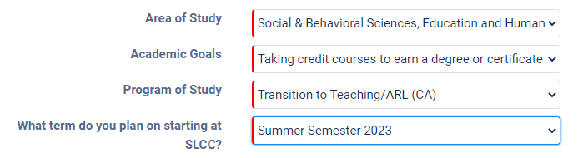

- Before signing the Student Agreement, make sure to check the box and save.
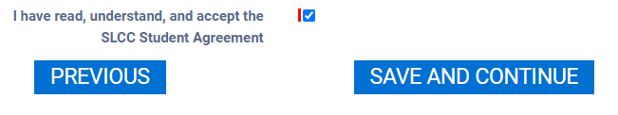
- Make sure all the boxes are checked as you move through the application.
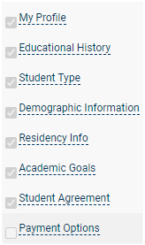
- If you have applied to the school in the last 3 years then your application fee will be waived. If you are applying to the school for the first time, or if it’s been more than 3 years, you will make the payment online or contact the cashiers office to pay for application fee.

- Make sure to submit your application.
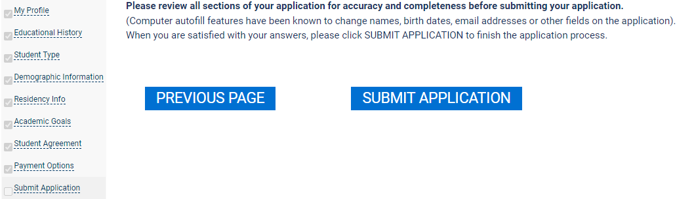

- When you return to the home page, click Application Updates and verify that the Admissions Status says “Complete App” and all fields have an entry.
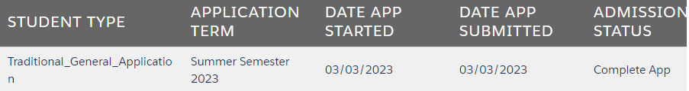

- Online admission applications are generally processed in 1-2 business days after they’ve been submitted.

Professional Development Student Record Management
at Salt Lake Community College

Office: (801) 957-5200
Fax: (801) 957-5328
AA/EO Institution
Professional Development Student Record Management
Salt Lake Community College
Miller Campus—MPDC 110
9750 South 300 West
Sandy, UT 84070
Office Hours: Mon—Fri 8:00am—4:30pm
Professional Development Student Record Management
Salt Lake Community College
Miller Campus—MPDC 110
9750 South 300 West
Sandy, UT 84070
Office Hours: Mon—Fri 8:00am—4:30pm

