YOUR BLACK IS BEAUTIFUL

C E N T E R I N G
B L A C K

E X P E R I E N C E S

TABLE OF CONTENTS

A LETTER TO MY NEPHEW BY JAMES BALDWIN 1
BOOK RECOMMENDATIONS 5
FILM RECOMMENDATIONS 7
AUDIO & PODCAST RECOMMENDATIONS 8
COMMUNITY INVOLVEMENT 9
CAMPUS INVOLVEMENT 10
DONATE 11
WHITE ALLYSHIP 12

i

A LETTER TO MY NEPHEW
by James Baldwin

December 1, 1962

Dear James,

I have begun this letter five times and torn it up five times. I keep seeing your face, which is also the face of your father and my brother. I have known both of you all your lives and have carried your daddy in my arms and on my shoulders, kissed him and spanked him and watched him learn to walk. I don't know if you have known anybody from that far back, if you have loved anybody that long, first as an infant, then as a child, then as a man. You gain a strange perspective on time and human pain and effort.

Other people cannot see what I see whenever I look into your father's face, for behind your father's face as it is today are all those other faces which were his. Let him laugh and I see a cellar your father does not remember and a house he does not remember and I hear in his present laughter his laughter as a child. Let him curse and I remember his falling down the cellar steps and howling and I remember with pain his tears which my hand or your grandmother's hand so easily wiped away, but no one's hand can wipe away those tears he sheds invisibly today which one hears in his laughter and in his speech and in his songs.

I know what the world has done to my brother and how narrowly he has survived it and I know, which is much worse, and this is the crime of which I accuse my country and my countrymen and for which neither I nor time nor history will ever forgive them, that they have destroyed and are destroying hundreds of thousands of lives and do not know it and do not want to know it. One can be-- indeed, one must strive to become--tough and philosophical concerning destruction and death, for this is what most of mankind has been best at since we have heard of war; remember, I said most of mankind, but it is not permissible that the authors of devastation should also be innocent. It is the innocence which constitutes the crime.

Now, my dear namesake, these innocent and well meaning people, your countrymen, have caused you to be born under conditions not far removed from

1

those described for us by Charles Dickens in the London of more than a hundred years ago. I hear the chorus of the innocents screaming, "No, this is not true. How bitter you are," but I am writing this letter to you to try to tell you something about how to handle them, for most of them do not yet really know that you exist. I know the conditions under which you were born for I was there. Your countrymen were not there and haven't made it yet. Your grandmother was also there and no one has ever accused her of being bitter. I suggest that the innocent check with her. She isn't hard to find. Your countrymen don't know that she exists either, though she has been working for them all their lives.

Well, you were born; here you came, something like fifteen years ago, and though your father and mother and grandmother, looking about the streets through which they were carrying you, staring at the walls into which they brought you, had every reason to be heavy-hearted, yet they were not, for here you were, big James, named for me. You were a big baby. I was not. Here you were to be loved. To be loved, baby, hard at once and forever to strengthen you against the loveless world. Remember that. I know how black it looks today for you. It looked black that day too. Yes, we were trembling. We have not stopped trembling yet, but if we had not loved each other, none of us would have survived, and now you must survive because we love you and for the sake of your children and your children's children.

This innocent country set you down in a ghetto in which, in fact, it intended that you should perish. Let me spell out precisely what I mean by that for the heart of the matter is here and the crux of my dispute with my country. You were born where you were born and faced the future that you faced because you were black and for no other reason. The limits to your ambition were thus expected to be settled. You were born into a society which spelled out with brutal clarity and in as many ways as possible that you were a worthless human being. You were not expected to aspire to excellence. You were expected to make peace with mediocrity. Wherever you have turned, James, in your short time on this earth, you have been told where you could go and what you could do and how you could do it, where you could live and whom you could marry.

I know your countrymen do no not agree with me here and I hear them. saying, "You exaggerate." They do not know Harlem and I do. So do you. Take no one's

2

word for anything, including mine, but trust your experience. Know whence you came. If you know whence you came, there is really no limit to where you can go. The details and symbols of your life have been deliberately constructed to make you believe what white people say about you. Please try to remember that what they believe, as well as what they do and cause you to endure, does not testify to your inferiority, but to their inhumanity and fear.

Please try to be clear, dear James, through the storm which rages about your youthful head today, about the reality which lies behind the words "acceptance" and "integration." There is no reason for you to try to become like white men and there is no basis whatever for their impertinent assumption that they must accept you. The really terrible thing, old buddy, is that you must accept them, and I mean that very seriously. You must accept them and accept them with love, for these innocent people have no other hope. They are in effect still trapped in a history which they do not understand and until they understand it, they cannot be released from it. They have had to believe for many years, and for innumerable reasons, that black men are inferior to white men.

Many of them indeed know better, but as you will discover, people find it very difficult to act on what they know. To act is to be committed and to be committed is to be in danger. In this case the danger in the minds and hearts of most white Americans is the loss of their identity. Try to imagine how you would feel if you woke up one morning to find the sun shivering and all the stars aflame. You would be frightened because it is out of the order of nature. Any upheaval in the universe is terrifying because it so profoundly attacks one's sense of one's own reality. Well, the black man has functioned in the white man's world as a fixed star, as an immovable pillar, and as he moves out of his place, heaven and earth are shaken to their foundations.

You don't be afraid. I said it was intended that you should perish, in the ghetto, perish by never being allowed to go beyond and behind the white man's definition, by never being allowed to spell your proper name. You have, and many of us have, defeated this intention and by a terrible law, a terrible paradox, those innocents who believed that your imprisonment made them safe are losing their grasp of reality. But these men are your brothers, your lost younger brothers, and if the word "integration" means anything, this is what it means, that we with love shall force our brothers to see themselves as they are, to cease fleeing from reality

3

and begin to change it, for this is your home, my friend. Do not be driven from it. Great men have done great things here and will again and we can make America what America must become.

It will be hard, James, but you come from sturdy peasant stock, men who picked cotton, dammed rivers, built railroads, and in the teeth of the most terrifying odds, achieved an unassailable and monumental dignity. You come from a long line of great poets, some of the greatest poets since Homer. One of them said, "The very time I thought I was lost, my dungeon shook and my chains fell off."

You know and I know that the country is celebrating one hundred years of freedom one hundred years too early. We cannot be free until they are free. God bless you, James, and Godspeed.

Your uncle,
James

"A Letter to My Nephew" was first published by James Baldwin in The Progressive magazine in 1962 and republished in his 1963 book, "The Fire Next Time."

James Baldwin

James Baldwin, a Black, gay American writer and playwright, was born in 1924 in Harlem, New York. The grandson of a slave, Baldwin was the oldest of nine children. As a child, he developed a love for reading and writing as a way to escape the realities to which he was subjected by a legacy of racism and anti- Blackness in the United States. Baldwin is the author of six novels and a dozen of essay collections. He is also the playwright of "The Amen Corner" and "Blues for
Mister Charlie." 4

BOOK RECOMMENDATIONS

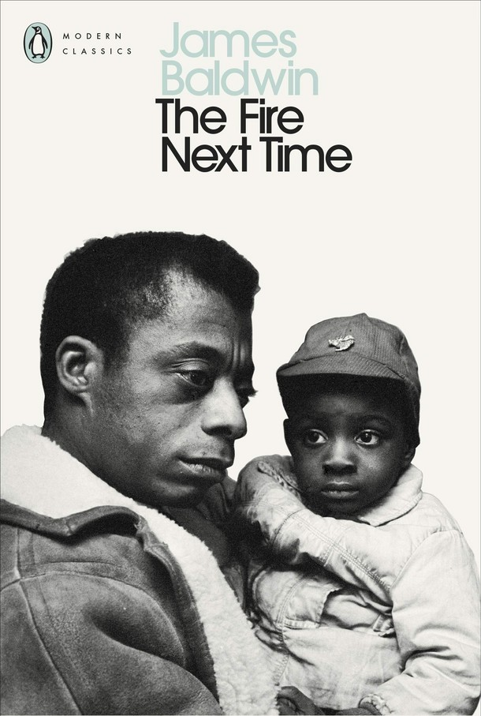
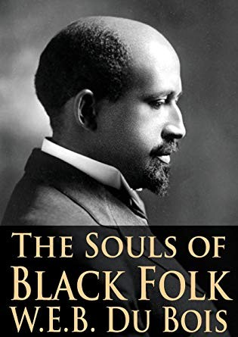

5

BOOK RECOMMENDATIONS (continued)

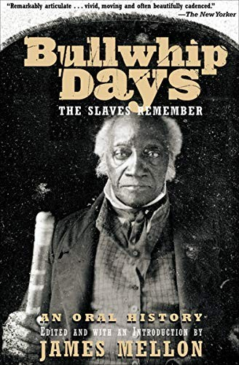

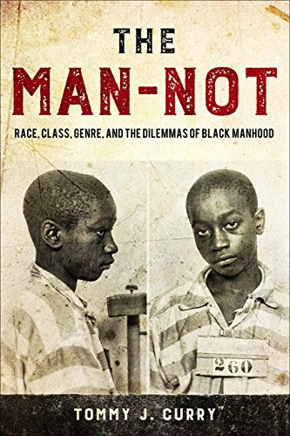
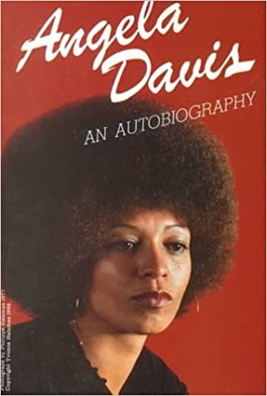
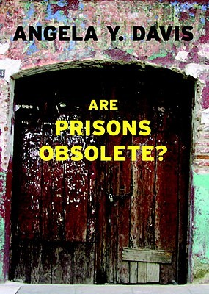

6

FILM RECOMMENDATIONS

7

AUDIO & PODCAST RECOMMENDATIONS

8

COMMUNITY INVOLVEMENT

The vision of the National Association for the Advancement of Colored People (NAACP) is to strive for a society in which all individuals have equal rights without discrimination based on race. The NAACP has a chapter in Salt Lake City and Ogden. https://www.naacp.org/

The Utah Black Roundtable is a community collaborative established to work on issues and solutions impacting the lives and well- being of Blacks/African Americans in Utah. https://www.utahblackroundtable.org/

Vote and participate in local and national elections to strive for representation. Hold our elected officials ACCOUNTABLE. https://vote.utah.gov/

Support Black Lives Matter - A local and national organized movement dedicated to non-violent civil disobedience in protest to police brutality and anti-Blackness. https://blacklivesmatter.com/

The African American Policy Forum (AAPF) is an innovative think tank that connects academics, activists and policy-makers to promote efforts to dismantle inequality. https://aapf.org/

9

CAMPUS INVOLVEMENT

@ bsu_slcc

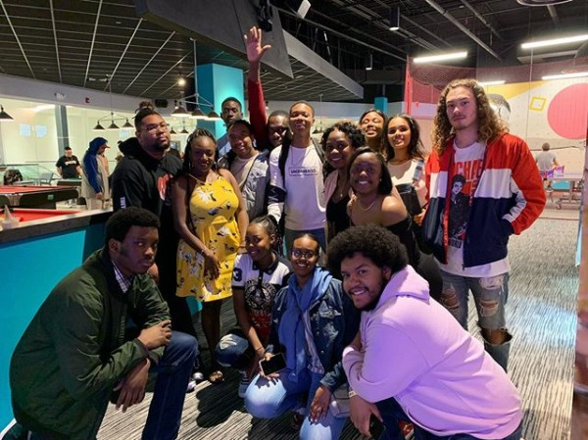
Salt Lake Community College Black Student Union

The SLCC Black Student Union (BSU) is a Multicultural club established circa 2003. BSU was first known as the “African American Awareness Association” or “4A’s.” In 2008, 4A’s members voted to change the club name to the “Black Student Union.”

The mission of BSU is to empower African, African American, and Black students through academic excellence, leadership development and programming. The vision of BSU is to instill a sense of pride and appreciation for Black cultures and heritages, while maintaining an open space for students to share and learn about themselves and each other.

Meetings: Thursdays from 12:00-1:00 P.M @ Taylorsville Redwood STC 223-225. Contact: jaycee.galvin7@gmail.com

Black Student Union Officers 2020-2021

President - Jaycee Galvin
Vice-President - Musafiri Chikobe (Musa) Communications Chair - Beringo Wa Masumbe Ne Treasurer - Yasmin Mahamud
Outreach Chair - Wisdom Agbabli Activity & Events Chair Sharifa Harrigan Advisor - Glory Johnson-Stanton
10

DONATE

S A L T L A K E C O M M U N I T Y C O L L E G E
M S . A L B E R T A H E N R Y
E N D O W E D S C H O L A R S H I P

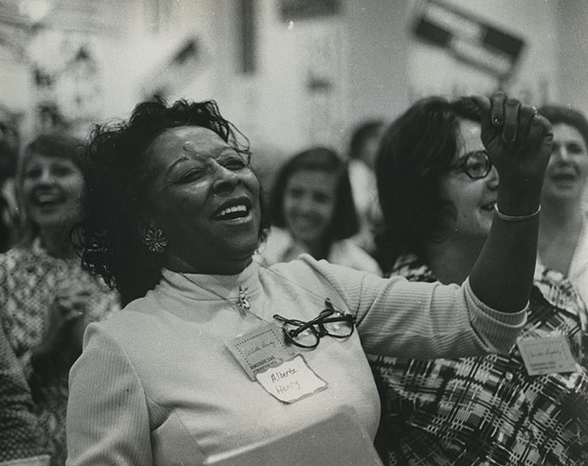

T h e M S . A l b e r t a H e n r y E n d o w e d S c h o l a r s h i p a t S a l t L a k e C o m m u n i t y C o l l e g e w a s e s t a b l i s h e d i n 2 0 1 7 b y t h e A l b e r t a H e n r y E d u c a t i o n F o u n d a t i o n , I n m e m o r y o f M i s s A l b e r t a H e n r y w h o w a s a n i n f l u e n t i a l c i v i l
r i g h t s a d v o c a t e i n t h e S a l t L a k e c o m m u n i t y f o r m o r e t h a n 4 0 y e a r s . T h e A l b e r t a H e n r y E n d o w e d
S c h o l a r s h i p i s f o r B l a c k / A f r i c a n A m e r i c a n s t u d e n t s a t S a l t L a k e C o m m u n i t y C o l l e g e w h o a r e d e d i c a t e d t o s e r v i n g o t h e r s t h r o u g h c o m m u n i t y s e r v i c e , W h i c h w a s
o n e o f M i s s H e n r y ’ s g u i d i n g p r i n c i p l e s i n l i f e .

STEP 1 | VISIT | http://bit.ly/SLCCGiving
STEP 2 | DIRECT MY GIFT TO | General Scholarship
STEP 3 | DESIGNATION | "Alberta Henry Endowed Scholarship" STEP 4 | CLICK | Process
11

WHITE ALLYSHIP

CHALLENGE:

Challenge your conscious and unconscious biases. Do you know what they are? If not, start by taking an implicit association test. We recommend implicit.harvard.edu.

Challenge your assumptions about the world. What do you consider "normal?" Which histories do you know? And whose experiences do you center? What kind of knowledge centers your world?

Challenge your privilege. We challenge you to acknowledge your privileges and how they perpetuate anti-Blackness and White supremacy.

DISRUPT:

What are some steps you can take each day to disrupt anti- Blackness?

As you gain more awareness, disrupt conversations that are anti- Black and racist.

Use your privilege (and your physical and financial resources) to support Black people, issues, local businesses, and projects.

DISMANTLE:

Know your place and stay in your lane. Let Black people lead Black movements. Pay close attention, listen, learn, and follow their lead. The system is inherently racist. How are you upholding White supremacy?

Dismantle ideologies of allyship. DO THE WORK. It is not the responsibility of Black people to teach you.

12

Office of Diversity and Multicultural Affairs 4600 South Redwood Road, STC 236
Salt Lake City, UT 84123
801-957-4954 | diversity@slcc.edu |
Facebook @SLCCDiversity | Instagram: @SLCC_Diversity | Twitter: @SLCC_Diversity

