How to Sync MySuccess with Outlook
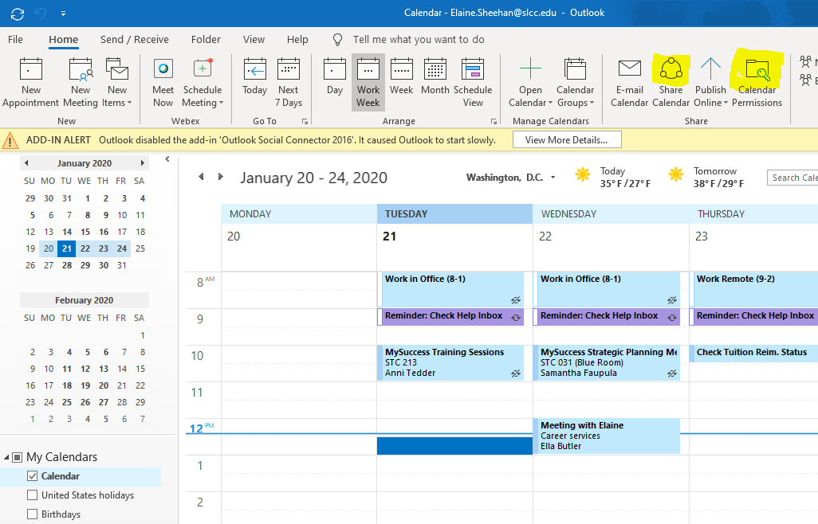
Sharing Calendar with Starfish
Sharing Calendar with Starfish
- Go to ‘Share Calendar’ in Outlook
- Share, full details with star.fish@slcc.edu

Creating Calendar Permissions
- Once shared, go to ‘Calendar Permissions’
- Find Starfish in the list
- Permission Level: Editor
- Read: Full Detail
- Write: Create Items and Edit All
- Delete Items: All
- Other: Folder Visible
- ‘Apply’

Syncing Calendar with Starfish
- In MySuccess, click on three bars in the top left corner
- Click on down arrow next to your name
- Click on Email Notifications
- Click box next to “Read busy times from my external Exchange Calendar”
- Click Submit

