Updated 11/15

Student Affairs
Site Review Team Handbook

Adapted with permission and appreciation from the Site Review Team Handbook by
Student Affairs at Weber State University.

Table of Contents

Purpose & Goals of Program Review………………………………………………………………… 3

Site Review Team Role and Responsibilities…………………………………………………….. 4

Site Review Team Selection ………………………………………………………………… 4

Self-study Report ……………………………………………………………………………….. 5

Site Visit …………………………………………………………………………………………… 5

Site Review Team Report ………………………………………………………………….. 6

Appendix A SLCC – Links to Information .………………………………………………….. 8
Appendix B Student Affairs Organizational Chart ………………………………….. 9

Appendix C Sample Site Visit Schedule and Team Timeline…..………………….. 10

Appendix D Program Review Standards .…………………………………………………… 12

Purpose and Goals of Program Review

The purpose of a program review process is to provide a comprehensive evaluation of individual departments within Salt Lake Community College’s Student Affairs on a five-year cycle. (See Appendix A and B for links to information about Student Affairs and for Student Affairs’ Organizational Chart.) Program review is a reflective process that allows departments to describe and assess their functions and services and identify areas that are performing well and areas that need improvement; it includes an external review that provides outside perspectives and recommendations. Program review also serves to assist with departments’ strategic planning and goal setting. Program review complements Northwest Commission on College and Universities’ (NWCCU) new accreditation standards that emphasize the importance of implementing frameworks for continuous improvement through self-reflection and synthesis of data.

Due to the in-depth nature of a program review, the review will be the department’s only required assessment for the academic year.

Goals of Program Review
- To ensure that each department is providing high-quality, effective programs and services.
- To continually strive to improve SLCC Student Affairs programs and services.
- To demonstrate department alignment with the division and institutional mission statements through an evidence-based process.
- To create recommendations and action plans and identify important initiatives to be used in strategic planning for the department, Student Affairs and the institution as a whole.
Each department will go through the program review process on a five-year cycle. As this is an intensive process, all department members of a department should be aware of the process and as many as possible should play an integral part. Each department will complete a self-study document (see Program Review Handbook) that addresses not only department data and statistics but also department needs, strengths, and areas for improvement.

Site Review Team Role and Responsibilities

The site review team typically consists of an out-of-state reviewer, an in-state reviewer from another institution, and an internal SLCC reviewer outside the department. This team is asked to examine and provide feedback on the departmental self-study document. During the site visit, the site review team will interview department members, students, Student Affairs staff and administrators as well as those from other areas, including faculty and community partners, if applicable. The purpose of the interviews is to assess the department’s relationships to stakeholders on campus and to follow-up on any questions or concerns that emerged from the examination of the self-study document.

The out-of-state reviewer will lead the team and provide insight from a national or other state perspective on trends and issues relative to the department being reviewed. The in-state reviewer typically represents a similar department at another USHE institution. The SLCC internal reviewer will provide context from the viewpoint of Salt Lake Community College. The out-of-state reviewer typically serves as the lead in facilitating the team and in writing the report, although the other reviewers will share summaries of their notes and may participate in drafting sections. All three reviewers will participate in providing suggestions and edits to the final document.

Responsibilities of the review team include:

- Collaborating with the other reviewers on the team,
- Becoming familiar with the Program Review Handbook,
- Evaluating the self-study document and additional materials provided by the department,
- Developing questions in preparation for the site visit,
- Interviewing department staff, students, Student Affairs staff, other department administrators, staff and faculty,
- Defining preliminary findings of strengths and areas of improvement for the department and presenting these at the end of the site visit,
- Sharing notes and observations with the lead reviewer for the draft report,
- Providing a written report (see format below) within two to three weeks following the site visit,
- Responding to and incorporating requests for corrections or clarification from the director and assistant vice president, and
- Finalizing and submitting the final report.

Site Review Team Selection

Reviewers are nominated by the department and approved by the department’s assistant vice president (AVP) and vice president (VP) of Student Affairs. The reviewers are then contacted and invited to participate in the site visit typically by the program review coordinator or by the director. The program review coordinator will follow up with a formal confirmation of the reviewers’ participation and the dates of the review.

The program review coordinator, director and the AVP of the department under review will be available to the site review team through email to answer any questions. The program review coordinator will work on travel arrangements and accommodations with the office of the VP of Student Affairs for the out-of-state reviewer and, if necessary, for the in-state reviewer.

Self-study Report

The self-study report will be emailed at least two to three weeks prior to the scheduled site visit. The standards by which to evaluate the self-study document are located in Appendix D. Questions that the departments were given to consider in the self-study document are located in the Program Review Handbook (see Self-study Components).

Members of the site review team will be expected to read the self-study and assess the components against the standards (Appendix D). Reviewers should make not of questions to ask departmental stakeholders during the site visit. Reviewers are encouraged to review the department’s website before the site visit. If reviewers want to request additional information, they can contact the program review coordinator. The out-of-state reviewer may communicate with the other two reviewers to share questions and discuss areas of interest they may want to explore.

Conference Call

The program review coordinator will schedule a conference call with the site review team and the department director one to two weeks after sending out the self-study. The tentative site visit schedule and interview assignments will be shared. The call is designed to help reviewers prepare for the visit, answer questions about the process and finalize the schedule.

Site Visit

The site visit schedule and logistics will be coordinated by the program review coordinator. The site visit will be approximately two days but this may vary based on the department. The out-of-state reviewer will be given time to meet with the two reviewers at the beginning of the site visit to discuss the review process, the self-study report, and the site visit schedule. The out-of-state reviewer will be the team leader for the site visit. At the end of the two days, the review team will have time to discuss and prepare their observations and recommendations.

Key times during the site visit include (see Appendix C for sample schedule):

- Initial meeting of reviewers to meet one another to review the schedule and discuss questions
- Tour of the facilities with possible visit to other campuses
- Lunches with the team, program review coordinator, director and AVP
- Meeting with the VP of Student Affairs and AVP
- Meetings with the director, staff and students who work within the department or use the services
- Meetings with other stakeholders such as administrators, staff and/or faculty from Student Affairs or other departments (and possibly the community if applicable)
- Time at the end of the visit for team to discuss the interviews, make observations and formulate preliminary findings
- Presentation of preliminary findings with director, AVP, VP of Student Affairs and program review coordinator at end of the site visit
- Exit meeting with AVP and VP of Student Affairs

Site Review Team Report

Preliminary Recommendations

Following the site visit interviews, the site review team will present its preliminary recommendations to the director, the AVP, the VP for Student Affairs, and the program review coordinator. These findings can be discussion items as opposed to a written report and could include initial strengths, areas of improvement, and any overall recommendations for future directions.

Final Report

The reviewers’ report should be emailed to the program review coordinator within two to three weeks of the site visit. This report should typically be ten to fifteen pages in length and should address the department’s alignment with the program review standards (Appendix D), areas of strength/commendations, recommendations of areas for improvement, and recommendations based on trends and best practices in the field. The observations/findings should include evidence or examples from the self-study and site visit interviews. Reviewers are encouraged to analyze whether there are gaps or needs that are not being addressed. Reviewers may find it valuable to share ideas or practices from other institutions or from professional associations with which they are familiar.

The format should include the following:
- Cover page listing the department, the reviewers with their titles, and the date of the final submission.
- Introduction or methodology explaining the sources used in the report (e.g., department self-study, site visit interviews, etc.) and limitations inherent in the observations or findings. This section should include a note such as the following: “This site visit report was prepared by three external reviewers based on a two-day site visit and the department’s self-study report. The observations based on the site visit are limited to information from those who were interviewed and may not reflect all points of view or perspectives.”
- Areas of strength with specific examples and evidence (refer to both self-study and interviews)
- Areas needing improvement or change with specific examples and evidence (refer to both self-study and interviews)
- Recommendations for future directions
- Pagination

The director and AVP may have questions about the report, concerns about factual content or requests for clarification. In this case, the lead reviewer should get feedback from the other reviewers and then will incorporate changes in the final report or explain why the team felt no change was needed.

Following the submission of the final report, the department will develop a plan of action after consultation with the AVP and the VP of Student Affairs. The plan of action will consist of short and long term goals from both the self-study and the reviewers’ report that will guide the department for the next few years.

The documents for the program review process including the department’s self-study, the reviewers’ recommendations (or an executive summary of it), and the action plan will be posted online on the VP of Student Affairs’ website.

Appendix A

Resources about SLCC and Student Affairs

About SLCC: Mission, Vision, Organizational Chart
http://www.slcc.edu/about/index.aspx

SLCC Institutional Research: Fast Facts, Surveys
http://www.slcc.edu/ir/index.aspx

SLCC Accreditation
http://www.slcc.edu/accreditation/index.aspx

SLCC Assessment, Accreditation and Planning: Student Affairs Assessment Reports
http://www.slcc.edu/assessment/index.aspx

SLCC Locations and Maps
http://www.slcc.edu/locations/index.aspx

Student Affairs Departments
http://www.slcc.edu/ssvp/index.aspx

Student Affairs Program Review
http://www.slcc.edu/ssvp/program-review.aspx

Appendix B

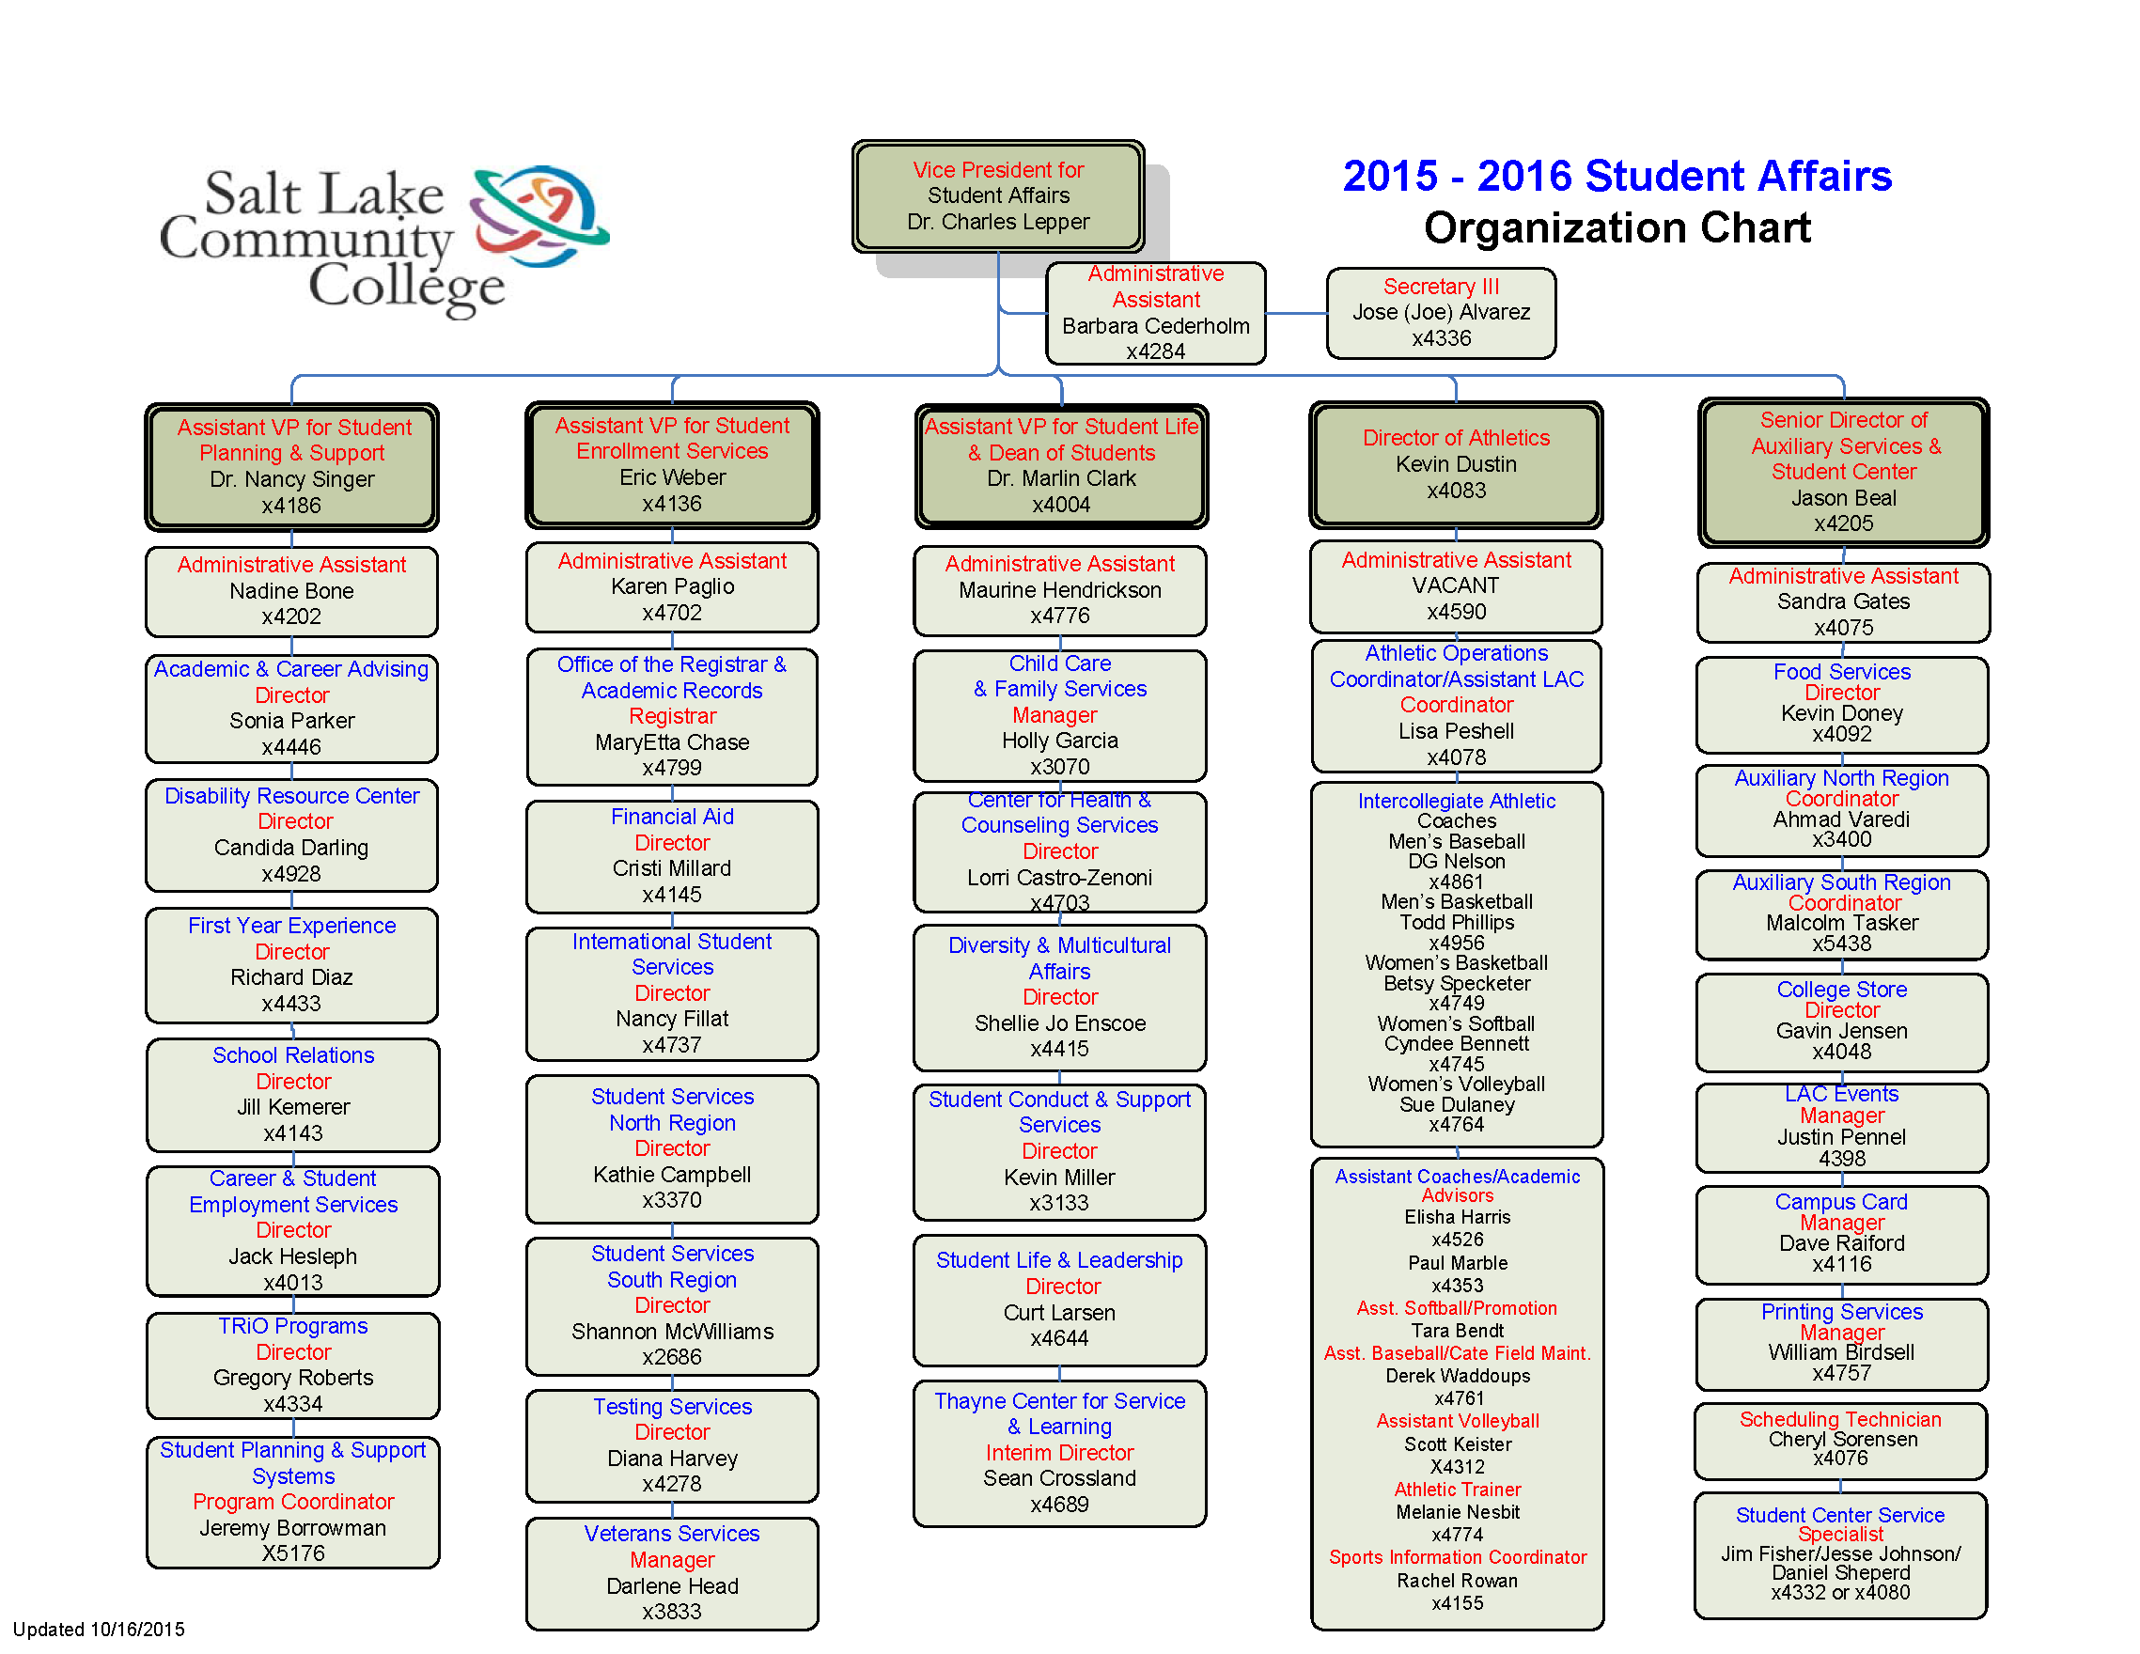

Appendix C

Sample Site Visit Schedule and Team Timeline

Before Site Visit

2-3 weeks Receive and read self-study report, review department’s website
1 -2 weeks Participate in conference call with other reviewers, program review coordinator and director to review site visit schedule and define areas of focus and interview assignments

First Day
_______ Out-of-state reviewer picked up at airport day of visit or at hotel if arriving night before

8:30 Site team welcomed by VPSA (if available), director and AVP; overview of Program Review

9:30 Site team meets with program review coordinator, director and AVP to review schedule, logistics and questions/areas of focus for interviews

10:00 Site team meets with director and AVP for overview of self-study; may meet with department staff as a whole

11:30 or 12 Lunch

12:30-4:00 Interviews (TBD- composition, order, length and reviewer assignment will vary)
Department staff Administrators
Faculty Student Affairs Departments
Community Students

4:00-4:30 Site team meets to discuss observations and plan for next day interviews

6:00 Dinner with out-of-state reviewer and others (TBD)

Second Day

8:30 – 12:00 Interviews (TBD – composition, order, length and reviewer assignment will vary)
May include visit to another campus

12:00 Lunch

1:00 – 2:30 Interviews (TBD – see above)

2:30-3:30 Site team meets to discuss findings and identify preliminary recommendations

3:30 – 4:00 Site team presents findings and preliminary recommendations to director, AVP, VP, and program review coordinator

4:00-4:30 Exit meeting with AVP and VP

5:00 Leave for airport (or take to hotel, depending on travel arrangements)

After Visit

1 -2 weeks Lead reviewer coordinates compilation of findings, recommendations and edits site team report with input and notes from other reviewers

3rd week Lead reviewer finalizes site team report and submits to program review coordinator

4th week Director and AVP respond to report with any questions and suggestions for clarifications

5th week Lead reviewer gets input from other reviewers regarding suggested edits, makes changes if necessary, and submits final report

Appendix D

Review Standards

1. Department Mission, Goals, and Outcomes
The department has a mission and overarching goals/outcomes statements which are consistent with and which support the College’s and Student Affairs’ mission statements and goals.

2. Programs and Services
The department provides a set of core programs/services which are central to and consistent with the department’s mission and goals. These programs/services are responsive to the needs of the department’s constituents, are cost-effective and, when appropriate, are supported by other departments or agencies both within and outside the College.

3. Leadership and Staffing
The department has a sufficient number of well-qualified employees (professional, support, student) to effectively provide the core programs/services offered by the department. Employees have clear and current job responsibilities. Employees are oriented to their roles, receive appropriate leadership and supervision, are provided with ongoing professional development opportunities, and are regularly evaluated.

4. Financial Resources and Budget
The department has a well-defined and participatory budget planning process. This process results in sufficient resources to meet the department’s core programs/services, staffing, facility, equipment, and technology needs.

5. Facilities, Equipment and Technology
The department has safe, accessible, and current physical facilities, equipment, and technological resources to support its core programs/services and personnel.

6. Ethical and Legal Responsibilities
The department is aware of and compliant with statutory and professional ethical and legal standards which apply to the department’s core programs/services, personnel, facilities, equipment and technology.

7. Assessment and Evaluation
The department has clearly defined and measurable core program/service and student learning outcomes which are consistent with the department’s mission and goal statements. These program/service and student learning outcomes are regularly assessed through both direct and indirect measures, and the results of assessment are shared among constituents and are used for decision-making and planning.

