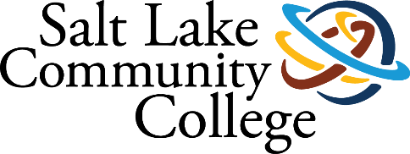 | CONTACT CENTER
2022-2023 ANNUAL ASSESSMENT
SUMMARY OF RESULTS

Project (Assessment) Title:
Online Success Coaching’s program (OSC) purpose is to increase online student engagement and retention through communication, collaboration, and accountability measures with Salt Lake Community College (SLCC). The coach’s goal is to proactively create a partnership with the online student. This is achieved by weekly communication with students to set goals, help students develop the skills and attitudes required to navigate college life, teach students to proactively connect to campus resources, and to empower lifelong learners. Through this process, OSC aims to increase retention, improve GPA, and enrich the online student experience. We are optimistic about the growth and success of the OSC program and success coaching moving forward. OSC continues to play a pivotal role in improving the remote services initiative recommended by the Strategic Enrollment Management CWT, ensuring that online students are afforded all the same opportunities and resources available to the on-campus population. As students are supported before, during, and after an entire semester, the data offers conclusive evidence that both student retention and GPA increases. The OSC program is confident in the approach for working with online students, and we see where the program can be applied to working with other student populations on campus with minor adjustments in content and delivery.
College-wide Strategic Goal
One of the College's primary goals is to increase Student Completion. The OSC’s purpose is to increase student retention and increase GPA which will set up coached students on a path that will increase completion. The OSCs meet with students throughout their coached semester to keep them on track for success and sign up for courses in the upcoming semesters that align with their Pathway.
For the College’s goal of Securing Institutional Sustainability & Capacity the OSCs provide access to resources on campuses that will help with their overall success. To assess the productivity of the coaches we have established weekly metric goals for outreach to students in their cohorts. With these metric numbers we also compile at the end of each semester numbers on retention to the next semester, GPA, and course completion.

Assessment Overview
Online Success Coaching is used to show the value of student engagement and connections. Research has shown that the more engaged students are, both academically and socially, the more likely they are to persist in college. One of the most significant factors in whether students feel engaged and have a sense of belonging is the level of connection to college personnel. The degree to which a student feels seen and cared about by faculty, administration, and staff informs how engaged that student feels, which affects student motivation to perform and persist. Online Success Coaching evolved in part out of a need to support online students by increasing engagement in the service of improving retention and academic success. We have worked with Data Science and Analytics to gather data to show the impact of coaching on student retention and success.

Methodology (Plan/Method)
Data, Science, and Analytics created and pulled reports of students who were coached from 2016-2023. These reports consisted of the following data: Name, Age, Gender, Ethnicity, Term program name, Term major, Term degree, First Generation Student, Ever Concurrent Indicator, Transfer in indicator, Full time, Undergraduate Credits to Date, Undergraduate GPA to date, GPA at the beginning of the term, GPA at the end of term, email, phone, text ok indicator, address, register for the following term, credits attempted, credits completed, calculated online, and calculated online sections. From these, we were able to look at retention, GPA increase, and outreach efforts.

Timeline
Summer semester 2016-spring 2023. In 2016, we were building and running the Online Success Coaching program at the same time. Cohorts were smaller for that reason. Thus, there will be some data from 2016, but most data gathered is from 2018-2023 because we had more coaches working with a group of 400 students per term.

Results/Finding (Disaggregated by race/ethnicity)
RETENTION: As online courses grow, so does the pressure to increase retention rates. Throughout each semester, coaches use a strength-based retention strategy by getting to know each student, personalize their support, and work to maintain student enrollment and keep them highly satisfied with their online experience. As the semester ends, coaches also encourage students to register for the next semester and help them plan their schedule.
Fall 2016 showed that 69% of coached students were retained into the following semester whereas, the non-coached control group only persisted at 55%. On average, collectively we found that coached students persist at a 68% retention rate while non-coached students only persist at a 44% rate. For Spring and Summer 2018, coaches took on the entire target population which is why there is not a control group.

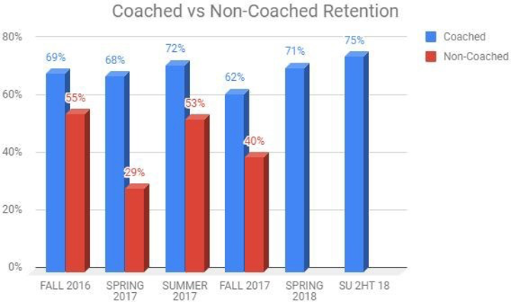
DATA: 843 Coached Students vs.411 Non-Coached Students, no control group for Spring and Summer 2018
From Fall 2018 to Spring 2022, our Online Success Coaches team grew in number as we were able to hire 2 more coaches in the Fall of 2018, and again in Fall 2020. Our team of 3 grew to 6 and allowed us to support more students. Thus, from 2018 – 2022 we were able to coach 11082 students. On average we were able to retain 62% overall.
We experimented with our cohorts as we pulled specific data to guide their creation. We piloted a group of students taking core classes such as ENGL 1010 and Math 1010. We worked with EDU 1020 instructors to support their students and coached CBE students when that program began. All these efforts were made to help identify students at risk and provide support in a timely manner.
We were able to use COGNOS reports to identify students within our coaches’ cohorts that have yet to register and execute various campaigns by calling, texting, and emailing to encourage students to register for the following term. This also helped to concentrate our efforts on retention while working with our student cohorts during registration periods.

The chart below shows the retention of each term for our students who were coached. As our coaching team grew, we had to expand our reach by including other categories of students. For instance, in the summer we did include guest students in our cohorts. Guest Students are defined as a student who is enrolled and completing a degree or certificate requirement at another college or university (primary Institution) and wishes to attend SLCC with the intention of transferring earned SLCC credits to their primary institution. Thus, in the chart below you will notice that summer retention drops significantly through 2021 and 2022 because we have a lot of guest students taking courses.
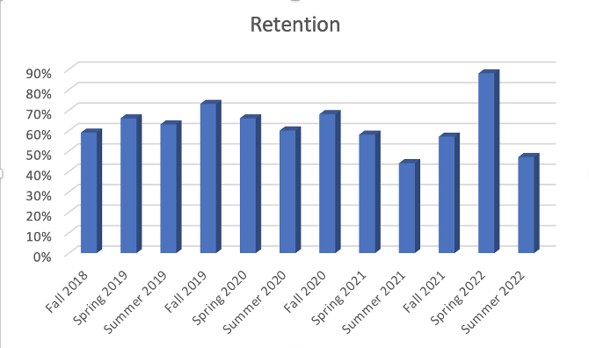
DATA: 11082 Coached students from Fall 2018 through Summer 2022, no control group during this time as all students produced by the COGNOS report were assigned to a coach.
STUDENTS OF COLOR: Research suggests that students of color are less likely to enroll in first year online coursework compared with White students (Jaggars and Xu 2010; Shea and Bidjerano 2014; Xu and Jaggars 2011). We were able to look at our students of color retention within our cohorts and found that on average 56% retained into the next semester. These students included American Indian/ Alaskan, Asian, Black/African American, Native Hawaiian/Pacific Islander, Hispanic, etc.
In Spring 2017, there was a total of 68 students and 82% retained. In Spring 2022, we had 615 students of color with a 91% retention rate.
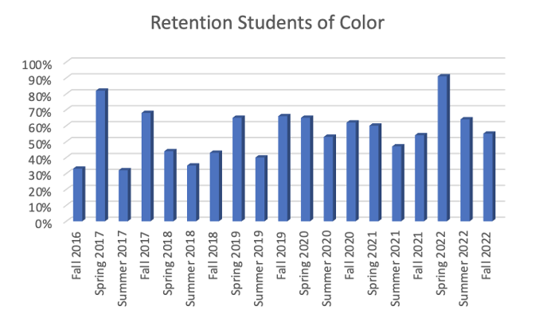
ACADEMIC SUCCESS: In OSC, we define academic success by GPA improvement. To determine success, at the end of each semester, we review all coached and control group final grades. By comparing a student’s cumulative GPA to their previous GPA, we can identify improvements. Students who achieved a 4.0 before and after, or transfer students were not considered.
The chart below compares those who had access to coaching services to those who did not. During the first semester of OSC, coached students collectively experienced a 48% improvement in their GPA, whereas non-coached students showed only a 4% improvement. This trend continues and on average from Fall 2016 to Fall 2017, 49% of coached students demonstrated an increase in GPA, as compared to non-coach students which averaged only 24%. Although numbers can be attributed to many factors, these figures were favorable given the correlation between OSC and academic success. For Spring and Summer 2018, coaches worked with the entire target population which is why there is not a control group.

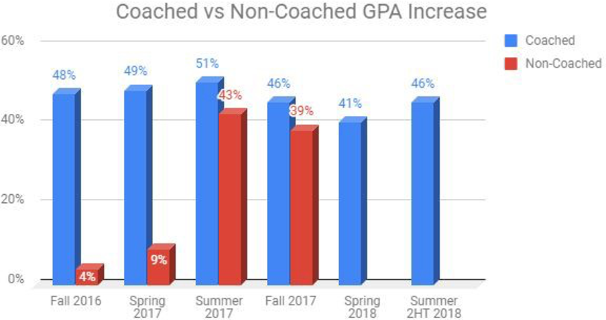
GPA INCREASE: From Fall 2018 through Spring 2022, 51% of our students overall showed an increase in their GPA by the end of the term. There were a few exclusions that included students who started with a 4.0 GPA and ended with a 4.0 GPA. Also, transfer students were not considered as they start with no GPA at the beginning of the term.

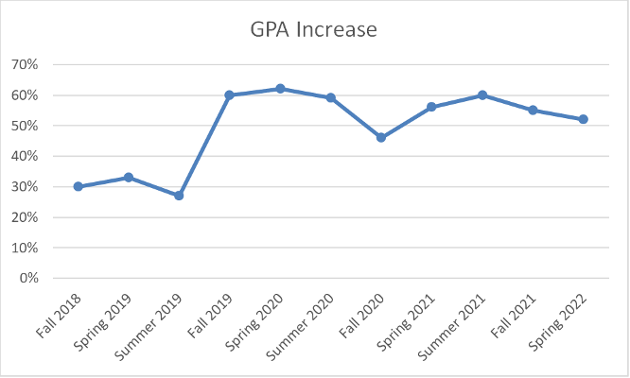
DATA: 11082 coached students average 51% GPA increase (excludes 4.0 & transfer students), no control group during this time as entire target group was assigned a coach.

OUTREACH: Outreach is an integral part of Online Success Coaching. Communication with student cohorts begins 4 weeks before the term begins so coaches can begin connecting with students to prepare them for getting started for the semester. Coaches will outreach to their students through phone calls, text messages, emails, and virtual appointments.

Below is a sample of our most recent outreach from Summer 2021 to Spring 2023. This data is pulled from MySuccess (Starfish). During this period, 21109 phone calls were made and this does not include any disconnected numbers, or full voicemails to which coaches were unable to connect. The 9163 phone calls are connections in which coaches could talk to their students. Thus, when looking at phone calls there are many attempts made to connect with students, resulting in a 43% connection rate. Appointments are typically conducted virtually or over the phone and there were 957 documented during this time. Text messaging has been successful with 12414 text messages being sent out. These text messages are not a part of mass texts that are sent out. These texts are sent out directly to individual students. coaches were able to connect via text 3460 times with their students, resulting in a 22% connection rate. Personal emails are personalized emails sent directly to the student, not in a mass email. There were 16762 emails sent directly to students, and coaches could connect with them via email 3892. The return rate for emails was 19%.

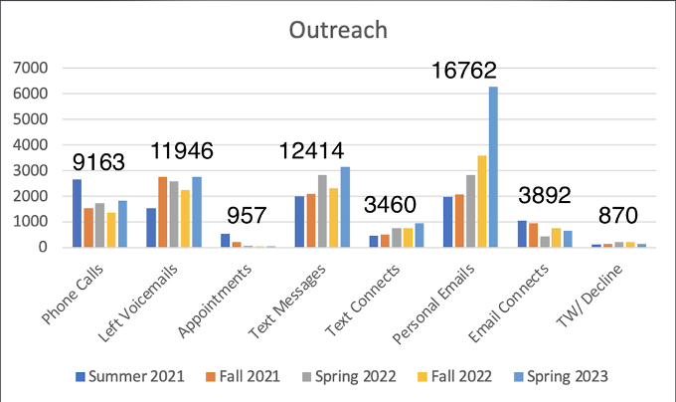

Action Plan (Use of Results/Improvements/Call to Action)
The OSC program is confident in the approach for working with online students and we see where the program that has been created can be applied to working with other student populations on campus with minor adjustments in content and delivery. Our hope is to work with Academic Affairs to learn more about other areas where success coaching can help with the retention, completion, and increase GPA of students overall at SLCC. We are currently working through a pilot with Academic Affairs on adding OSCs who are adjunct faculty who will be coaching a limited number of students and teaching up to 6 credit hours. We also discussed expanding online success coaching to the degrees identified as fully online for students to complete.

Other Notes
The OSC report compiled at delivered to the Executive Cabinet is the primary document for this assessment.

