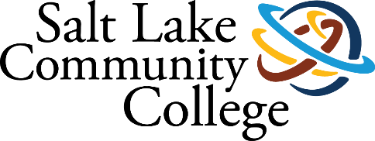 | International Student Services
2022-2023 ANNUAL ASSESSMENT
SUMMARY OF RESULTS

Project (Assessment) Title

Analysis of Student Outreach Regarding International Orientation and Visa Approvals

College-wide Strategic Goal

Secure Institutional Sustainability & Capacity

Assessment Overview

To assess our current outreach to newly admitted international students and create ways to improve outreach.

Methodology (Plan/Method)

We will describe our current outreach process for newly admitted international students and evaluate what is working and what is not working. This evaluation will be based on results from student input from an online survey as well as from emails from students who claim they have not been contacted after their application was submitted in a timely manner.

Currently, international students are only processed for admission for the current semester. All other applicants for future semesters must wait until the current term students have been processed before any other applications are examined. Documents and messaging are sent out randomly after each application is completed. There is also no system in place to track messaging or if students have received their student visa or not. This prevents us from knowing when a student needs to defer their admissions to another semester or providing additional support to help the student be successful. Also, students may or may not receive all the messaging information because of human error. If we were able to track this data, it would help in recruitment and retention efforts to increasing enrollments.

What is working:
- Standard messaging is being automatically sent to international applicants.
- Orientation online storefront is updated each semester.

What is not working:
- We do not know who has received their F-1 student visa to enter the U.S. because we do not have access to those federal records.
- We currently do not know who needs to defer their admission to the next semester. This is not an automated process.
- We need improved outreach for registering for the mandatory international student orientation. Current outreach to the students has been done inconsistently.
- We need a way to track and use this information.
- We have language barriers between us and some of our new students.
Note: We also plan to include a disaggregation of data by race/ethnicity if we notice any changes in specific populations. We will also include in our data the number of first-generation students.

Timeline

Fall 2022:

September: Review current outreach practices. Update the Orientation Storefront to reflect registration all year round (this has yet to be completed but will for Fall 2023).

October: assess what is working and what is not working.

October: Produce ideas to implement for the Spring 2023 semester. These ideas are listed below in January’s timeline.

November: Begin implementation of ideas.

December: Begin tracking and sending out information. A bulk email will be sent out the week of December 12th.

Spring 2023:
January: gather data on suggested improvements.

- We will collect data from F-1 visa holding students by way of a survey seeking information about prospective students.
- We will gather information on students who arrived to attend classes in the Spring semester.
We are looking for information on whether the students had difficulty obtaining their student visa as well as information if they are a 1st Generation college student.
- We plan to make that information available to TRIO and/other groups who could provide additional services to these students.

February: Review admissions data from survey results, orientation sign-ups, orientation attendance, and port of entry records and see if there are improvements.

March: Implement changes that have worked to international admissions process.

April: Write up assessment report.

May/June: Finalize assessment report for submission.

Results/Finding (Disaggregated by race/ethnicity)

- Addressing problems 1 and 2:

We do not know who has received their F-1 student visa to enter the U.S. because we do not have access to those federal records.

We currently do not know who needs to defer their admission to the next semester. This is not an automated process.

Our staff has noticed some difficulties during the international admissions process. While processes are in place to admit international students, we have noticed some problems that might be improved upon if we had additional data and information. Being able to know which students were able to obtain a student visa or not could aid in more follow up and deferring students to a future term. We also noticed that applications were only being processed for the current term and students were waiting for longer periods of time if they applied earlier than the current term. Furthermore, students continue to face more scrutiny when they apply for a student visa which could result in a denial and postpone their educational goals. Therefore, International Student Services (ISS) staff have created some surveys to collect information that could provide information on how we could make improvements to our internal processes for clarity and efficiency.
NEW POST-APPLICATION SURVEY.
Jotform is a powerful online application that allows anyone to quickly create custom online forms. Its intuitive drag-and-drop user interface makes form building incredibly simple and doesn’t require you to write a single line of code. Using Jotform, you can create and publish forms, integrate them into your site, and receive responses by email. (From https://www.jotform.com/faq/ ) It also allows the user to access data and generate reports in a very easy manner.
Using Jotform, Mia Escobar created and coded a POST-APPLICATION SURVEY to:
- Learn who has received their F-1 student visa to enter the U.S
- Know who had their visas rejected.
- Obtain a list of students who need to defer their admission to the next semester.
- List students who plan on getting a new visa appointment.
- List students who do not plan to get a new visa appointment.
- Remind students of the mandatory international student orientation.

POST-APPLICATION SURVEY was then embedded in an official email which was sent to all students with active applications.
The outcome of the survey is a shareable, printable, exportable, and fully editable report which shows the relevant data and allows the user to create charts and graphs for easy processing of the information.
You may see the survey here https://form.jotform.com/221884379019061
Once the students started taking the survey, we were able to access the data easily through customizable tables and charts. The data provided us with information about who was able to obtain a student visa or not. This information is important so that we can gain an idea of the number of students who are planning to attend for a given semester and know who we need to reach out to provide additional support and guidance. Many international students fail their first visa appointment and by knowing this early on we can provide additional help so that they can be successful at a future attempt. Information about the visa interview is sent to student but many of them do not review it or ask clarifying questions if they are confused.
For the Spring 2023 semester we had 60 students respond to the survey. For the Summer 2023 semester we had 51 students respond to the survey. The total number of responses was 111. This number was greater than expected. This survey will be updated and combined with the other survey which asked about first-generation students so that all questions can be more efficiently combined into one survey. We will continue to send out this survey each semester.
With this data we are also able to help students who are not successful in their first visa interview by deferring students to the next semester. If we know that a student was not able to receive a visa we can reach out to the student and create updated documents so that they can continue their educational plans for the next semester rather than giving up completely. If we can be notified early, then we can follow up quickly and have a better chance of retaining the student for enrollment.

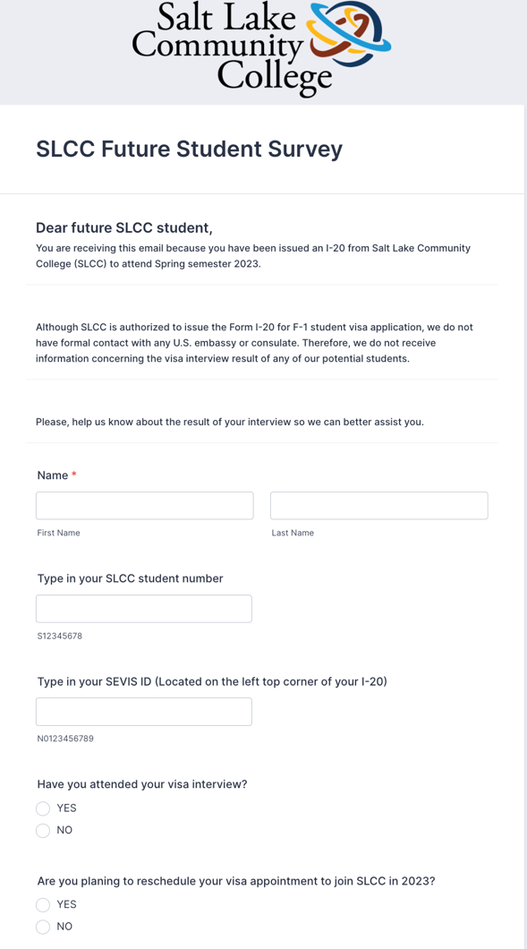
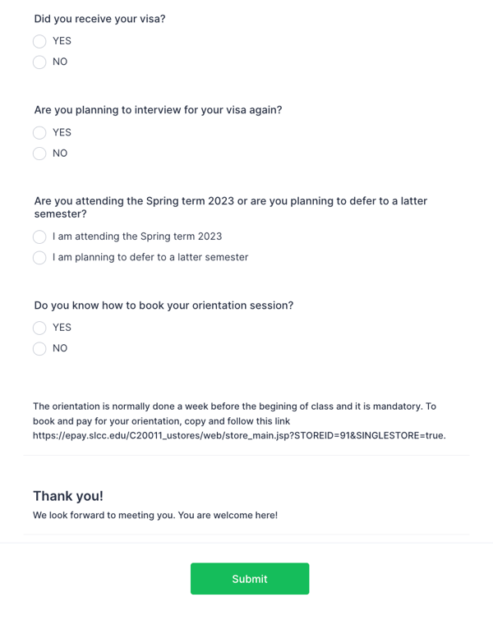

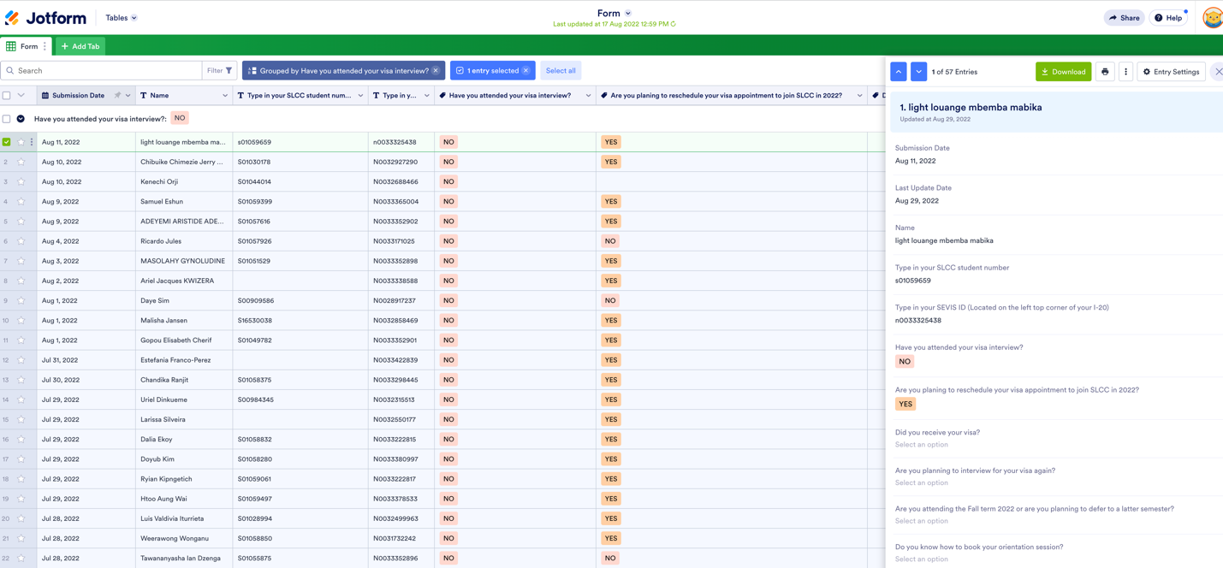

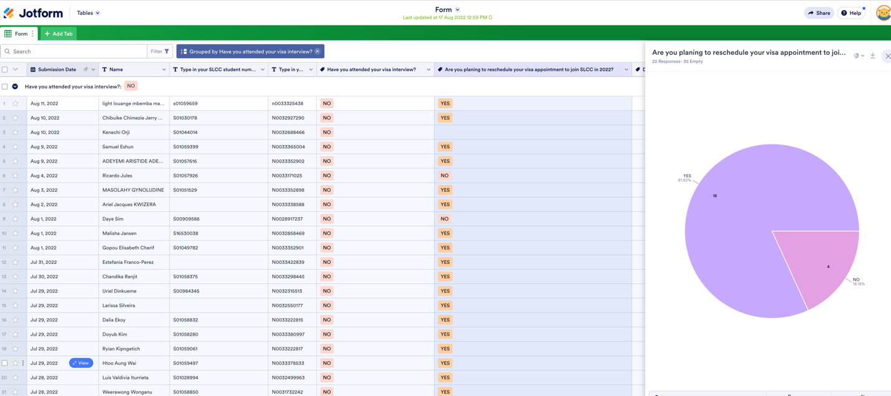

- Addressing problem 3:
We need improved outreach for registering for the mandatory international student orientation. Current outreach to the students has been done inconsistently.

- PRE-ORIENTATION SURVEY: 1st email that includes the survey.
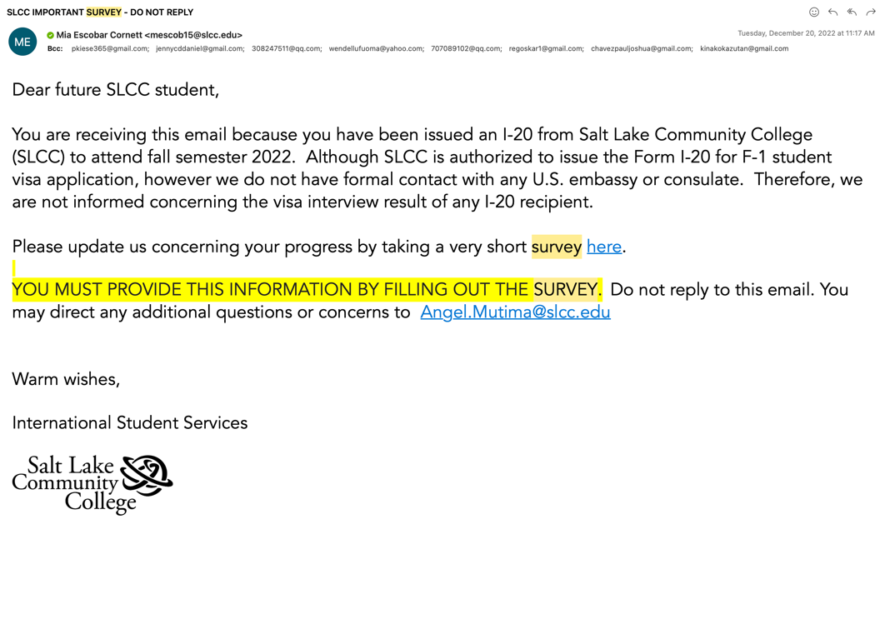

As well as accomplishing the objectives presented above, the PRE-ORIENTATION SURVEY includes a question to find out if students know how to book the mandatory orientation session and gives them the link to do so in case they express they do not know how.
For the Spring 2023 semester 22 students knew how to follow the link and instructions for registering for the international orientation and 9 students did not know or had questions. For the Summer 2023 semester 14 students knew how to register for the international orientation and 10 did not know or had questions.
This document is sent by email three weeks before the start of the semester. If students are having difficulties, we can address any problems and assist students in being registered and prepared for the mandatory international orientation.
- INVITATION TO ORIENTATION AND PRE-ORIENTATION RESOURCES: 2nd email.
A second communication is sent two weeks before the start of the semester and again one week before. Any students who are admitted late or might have additional questions or concerns can have this information on hand to prepare for the upcoming semester. The purpose of this message is to:
- Remind students of the mandatory orientation.
- Send a user-friendly document created by ISS which includes crucial information about Salt Lake Community College (SLCC) and the links to obtain in-depth details about it.

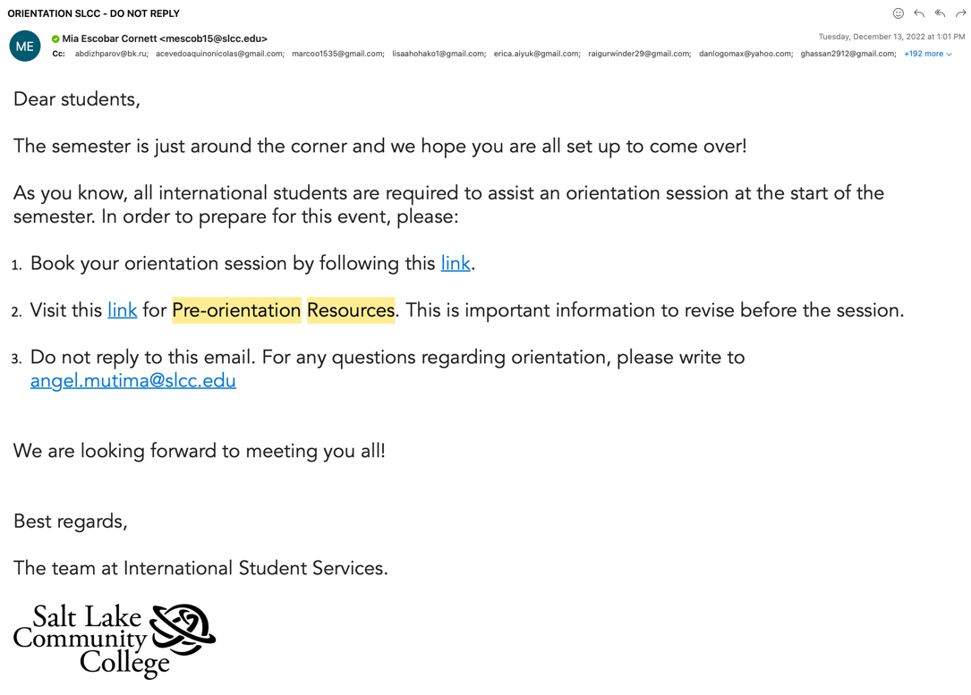

You can see the PRE-ORIENTATION RESOURCES here.
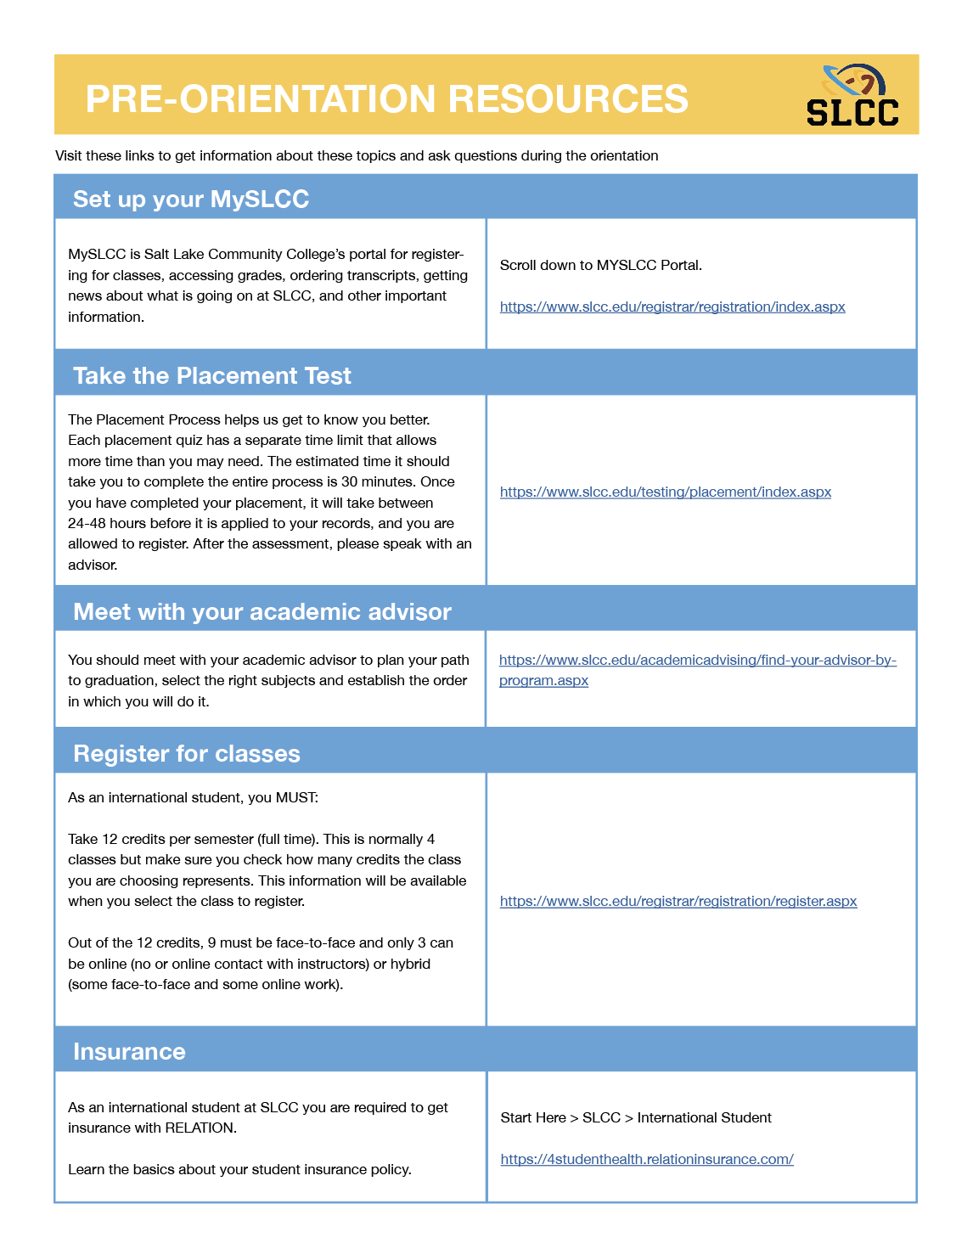

- POST-ORIENTATION RESOURCES: 3rd email.
Two days after the international orientation, an email is sent to all students which includes additional resources discussed during the session as well as a reminder of the upcoming second orientation. Since there is a lot of important information students will need to remember these resources have been created so that students can save them for future reference. By tracking this data, we can be sure that every international student has been given the information to help them maintain their immigration status. When students come to the office advisors can also refer the student back to the message which contains this information and/or can resend the information if it has been lost or deleted.
You can see the POST-ORIENTATION RESOURCES here.
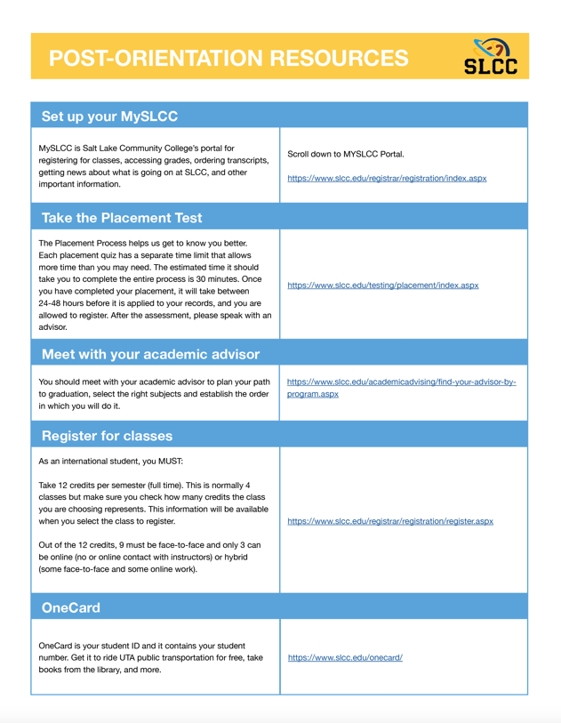

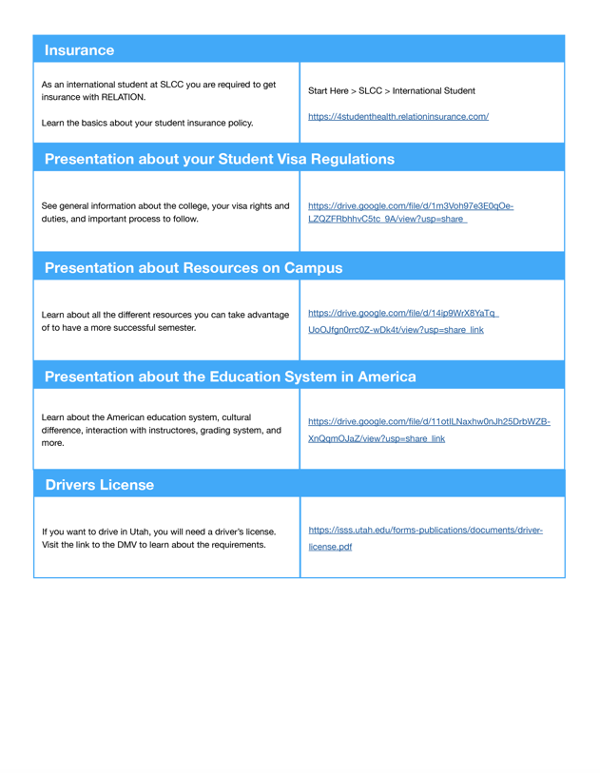

- Second orientation – Orientation Connect.

The second day of the international orientation, Orientation Connect, takes place a couple of weeks after the beginning of the semester when students have had some time to get settled. During this one-hour session, students meet with one of the international advisors and reviews vital information regarding their immigration responsibilities and to assess their comfort and adjustment in the navigation of the American education system, and use of campus resources.
ISS offers three options for students to join this online zoom session without clashing with their classes. International students are required to choose one time slot that will work with their schedule for this second orientation or Orientation Connect.

- Addressing problem 4.

The need for a tracking system.
Given the nature and quantity of the input involved in the international admissions process as well as the complexity embodied in its numerous specific cases, ISS has been working on refining a unified tool to track the data.
Some of the challenges Admissions faced:
- Processes involve numerous platforms: Salesforce, ISSM, SEVIS, emails.
- Communication between these platforms is not always reliable or efficient, requiring manual input which exposes us to human error and loss of data.
- It seemed necessary to have a visual on high, medium, and low priority cases while still processing all incoming applications.
- We needed to develop a tool that would provide us with indicators to monitor the process and that was safe, systematized, unified, user-friendly, and accessible to all team members.

After evaluating our needs, a team consisting of Rob Robbins, Mark Johnson, Angel Mutima, Lamia Sultan, and Mia Escobar proceeded to go through the entire admissions process based off the results of our surveys and make a list of the different input and products that needed recording, synchronizing, and monitoring. As the admissions process involves multiple software systems which do not communicate with each other a comprehensive tracking system needed to be put in place. Mia Escobar was then assigned to develop the tool.
Over the last several weeks Mia created an Excel spreadsheet which would be used to store the admissions data and could be used to sort data for admissions purposes. She successfully combined the required data into one tracking system that staff could use and quickly see immediately completed or incomplete items.
INTERNATIONAL STUDENT SERVICES TRACKIG SYSTEM - OVERVIEW.
Drop-down menus were implemented to minimize human-error and facilitate the use of filters.
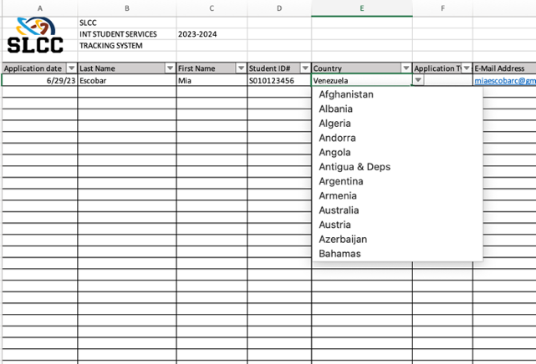

All the applications are recorded and split into two alphabetical groups. Each of the Specialists in the Admissions team are assigned a case load and works on their specific cases individually. Mark Johnson, or any involved party, can monitor both sheets from different tabs.
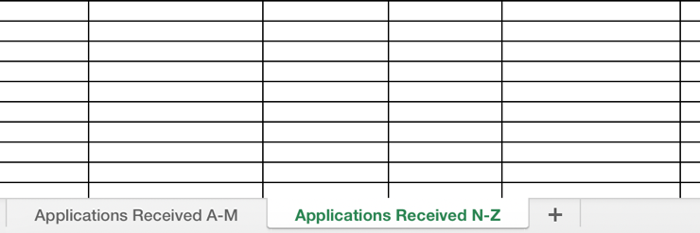

A color-coded system allows for a visual display on any specific application. Combined with application dates and deadlines, all team members can easily determine priority levels.
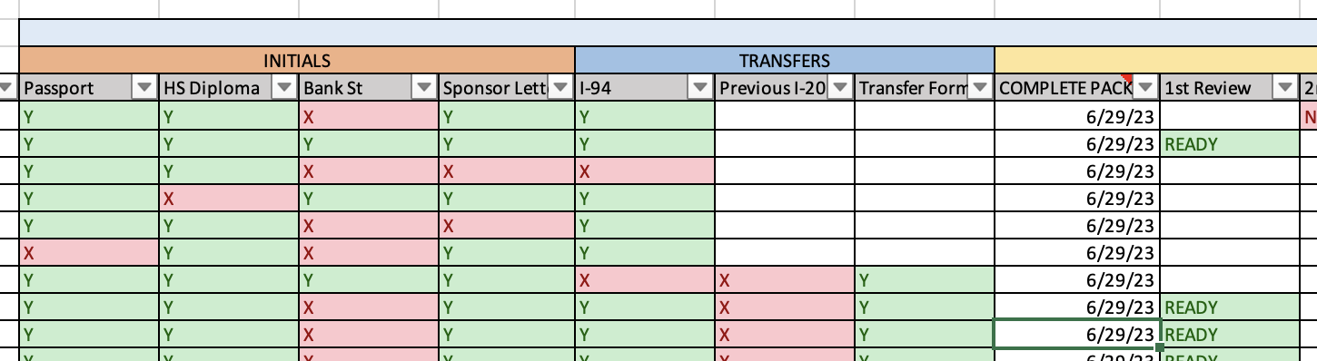

A simplified communication tool was included to follow up on potential issues without resorting to emails and their associated problems.
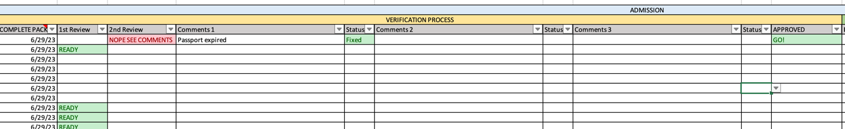

Filters were placed to further allow the admissions team to process applications efficiently.
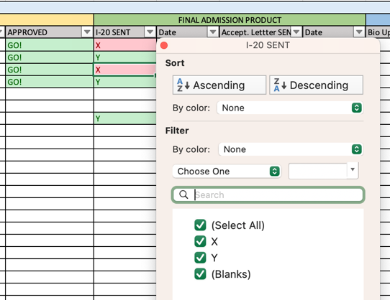

Finally, a follow-up section was added to record and monitor post I-20 products/services.
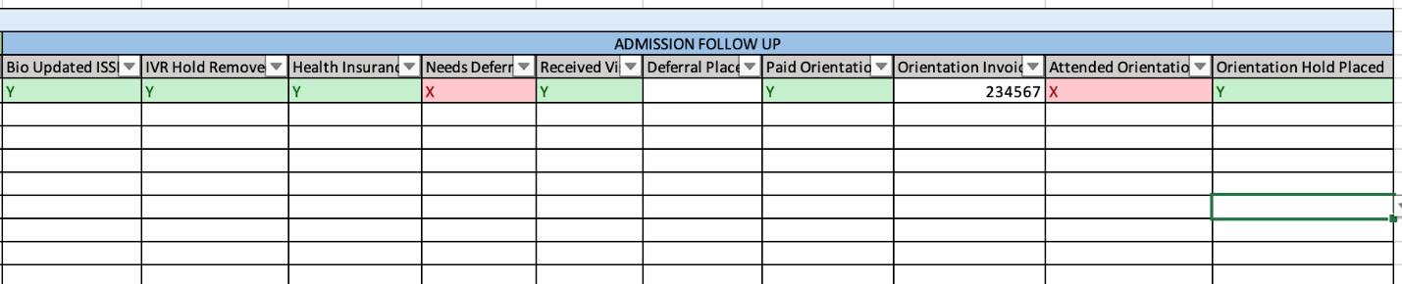

The tracking system has been uploaded to the SLCC secure servers for full access by the involved team members and they have been trained to use the tool and follow universal procedures.

- Addressing problem 5.

We have language barriers between us and some of our new students.

Misunderstanding language can represent a problem when supporting our students. Rob Robbins has tried to purposefully hire international students who can contribute to helping with this issue. In the last year we have been able to assist students who speak French, Spanish, Japanese, Arabic, Chinese, Portuguese, Sona, Ndebele, Tongan, and Swahili.
This has intentionality yielded more than language-related benefits: having international students assisting other international students has created an atmosphere of empathy, understanding, support, and tolerance within the office and the international student population.

- Determining 1st Generation students and level of difficulty in visa acquisition processes.

Using JotForm, we developed and sent a survey to students to determine if an international student was a first-generation student or not.
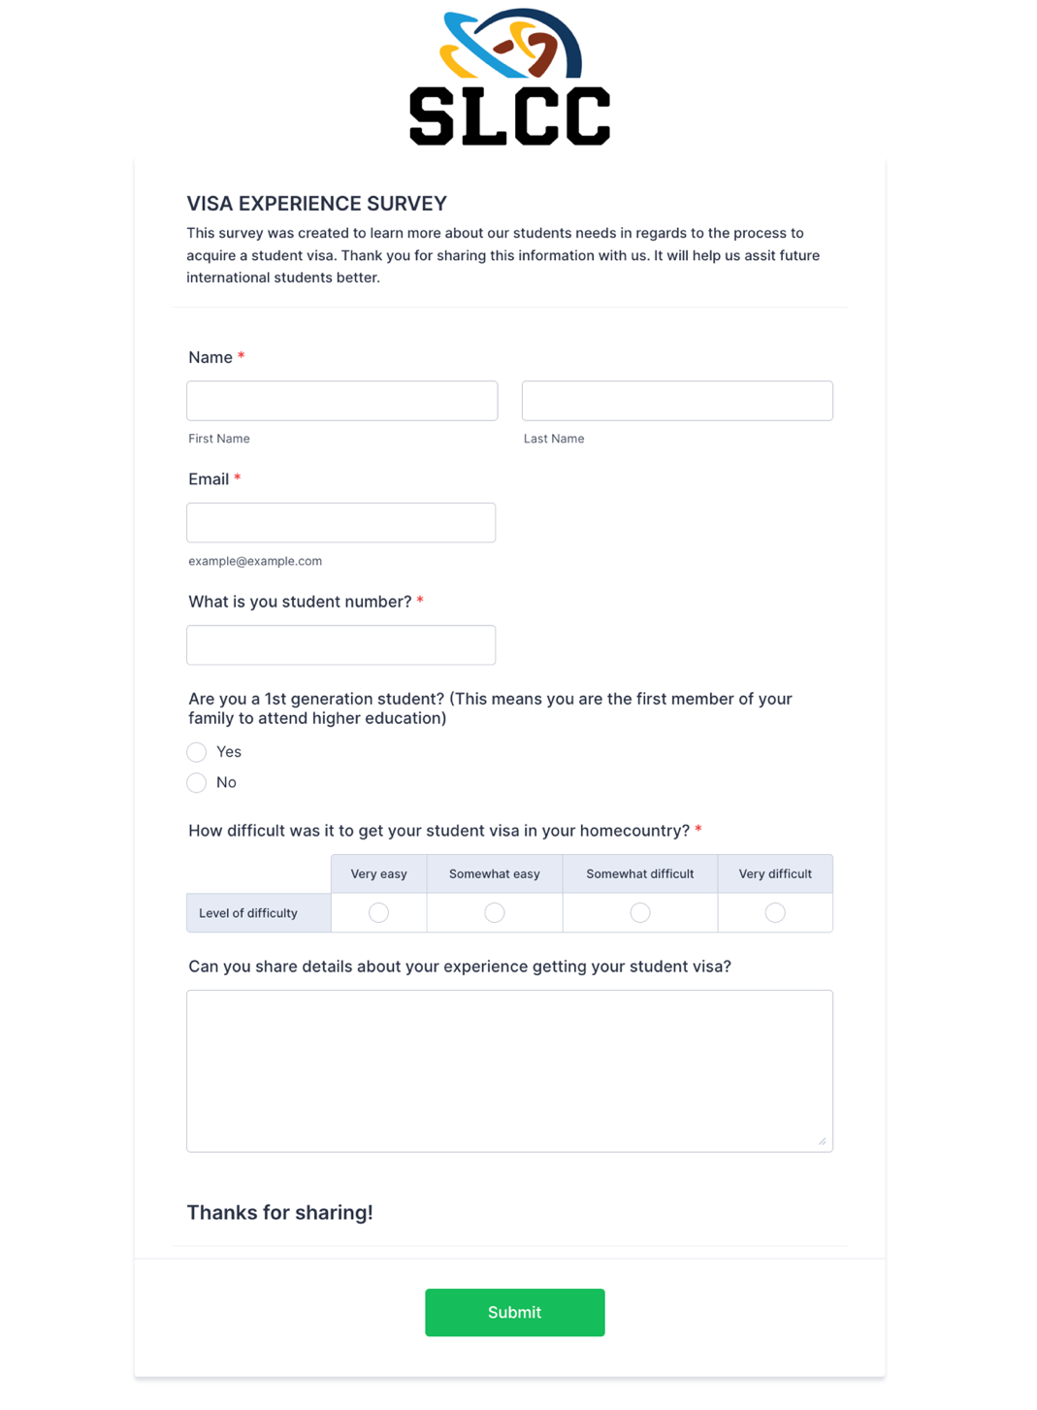

To see the visa experience survey, visit: https://form.jotform.com/231026075155044

The results of our survey showed that out of 8 responses to our survey that 6 are first-generation international students or 75% of those surveyed. With this information we can have a list of students who might be considered for additional support. This survey will be combined with the first survey to improve efficiency and not send too many messages out for student to have to respond back.

Action Plan (Use of Results/Improvements/Call to Action)

As a result of the surveys and data that was collected the International Student Services team created and implemented an Excel tracking system. The data showed that there were unaddressed problems for staff and students during the international admissions process. While some information cannot be accessed due to Federal Law, the information that could be collected and accessed were used as a template and guide to create our comprehensive tracking system. This system allows any staff member who has access to this information to know immediately where each international applicant is during the international admissions application process. It also tracks and indicates which student application is complete or incomplete. Staff can also be consistent in their messaging to each student and see when and what each message a student receives. Moving forward, this system will allow all international applicants the ability to apply to SLCC for any term and have their documents processed in a timely manner so that they can apply for a student visa. Applications for multiple semesters can now be processed simultaneously. This will remove any time barriers for applicants waiting for the current term to be processed ahead of future terms. We will now have the ability to process each application in the order it was received for any term.

Additionally, we will have data which can be used to assist students who need to be deferred to a future semester. Being able to see this information and communicate with students will allow us to retain and enroll students for future terms.

The data has allowed us to improve our tracking and communication with all our international student applicants. The staff are now able to provide support and information consistently and quickly to all new international students for multiple semesters during the year.

Other Notes

Special Thanks to:

Rob Robbins – Director
Michael Hasfurther – International Advisor
Mark Johnson – Admissions Advisor
Laura Klingenstein – Special Populations Advisor
Mia Escobar – Administrative Assistant
Nayara Borges Guerra – Admissions Specialist
Lamia Sultan – Admissions Specialist
Angel Mutima – Admission Specialist

