Thayne Center for Student Life, Leadership, & Community Engagement
2022 – 2023 ANNUAL ASSESSMENT

Project Title
Change in Bruin Pantry Usage, October 2019 to April 2023

College-wide Strategic Goal
Strategy No. 6 – Emerging HSI
Strategy No. 9 – Increase College Participation

Assessment Overview
Recent and rapid increases in Bruin Pantry use correlates with increased community need like rising cost of living in the Salt Lake valley, rent and gas price increases, stagnant wages, etc. In response to these compounding factors, Thayne Center has increased partnerships with community organizations to stock pantries and substantially refocused student fee dollars to address staffing needs and supplement food and hygiene products. While addressing these necessary changes, Thayne Center has made cultural changes to improve its service to students of color. This assessment analyzes newly available data to compare changes over the past three and half years in the Bruin Pantry network, including identity-based trends. As a result, Thayne Center finds support for its recent efforts, presents data-based insights to continue resource flow toward the Bruin Pantry, and, for the first time, speaks directly to visitor demographics. The report is timely for the institution as it emerges in its HSI work and prepares for a fifth pantry location opening at the Herriman Campus in Fall 2023. Special thanks to Institutional Development, who, in partnership with DOMO, made this assessment project possible.

Assessment Questions
- How much has student use of the pantry changed from October 2019 through April 2023?
- How have visitor demographics changed over the past 3.5 years?
- What are the demographics of current student pantry users? How well does this usage compare with student body demographics? Categories are provided in partnership with Information Technology and are connected to S-number and one-card data.
  - Gender: Male, Female, Neutral
  - Race & Ethnicity: African American, Asian, Caucasian, Hispanic/Latino/Latina, “More Than One Race”, Native American, “Non-Resident Alien,” Not Specified, Pacific Islander
  - First Generation Student
  - Veteran
  - Student Athlete
  - Employee

Methodology & Data Disaggregation by Race/Ethnicity
In Spring 2022, Thayne Center began utilizing DOMO software to better analyze data about pantry usage, which gave new life to data sets dating back to October 2019. Prior to this software, data analysis was limited to total number of visits and could not be disaggregated. To minimize barriers to visitors, Thayne Center personnel asks visitors to quickly tap their one-card or provide their S-number. Thayne Center’s data collection tracks the point in time a visitor enters the pantry and the specific location within the network (Taylorsville Redwood, South City, Jordan, West Valley Center). On a monthly basis, representatives in Information Technology collect this data from the Thayne Center, add demographic information, and remove visitor identifying information. Through this process, each visitor is coded, allowing for analysis of multiple visits and disaggregation by specific visitor.

Previously, DOMO dashboards reported for ‘current semester’ usage, primarily used as a tool for partnership with Institutional Development. For this project, Thayne Center staff built new DOMO dashboards that could evaluate multi-year usage, including disaggregation by identity groups connected to IT database information. To show changes over time, visitors in this report are grouped in ‘Years.’

Challenges & Limitations
Data collection began mid-semester in October 2019. Additionally, at the time of this report, data for Summer 2023 is incomplete. This limits data year-to-year change analysis to common points between October 2019 – April 2022. With the goal to analyze change over time, the measuring unit of “one-year” differs slightly as the fourth cycle has yet to complete. In the case of “Year 1” this includes data from fall 2019, spring 2020, and summer 2020. On the other hand, the most recent “year’s cycle” includes data from year three (summer 2022) and year four (fall 2022 and spring 2023). To ease comparison, this most recent yearlong cycle is entitled “Year 3.5.”

Furthermore, two significant interruptions occurred during data collection, likely impacting pantry usage and visits. First the COVID-19 pandemic shifted pantry visits in March 2020 from in-person client choice to a pre-packaged, low-contact pick-up structure. Pre-packed, low-contact pick-up was utilized again in January and February 2023 during the relocation of the Taylorsville Redwood campus pantry from STC 015 to its new, larger storefront in STC 020.

Findings & Interpretation
How much has student use of the pantry changed from October 2019 through April 2023?
With the conclusion of Spring 2023, Bruin Pantry welcomed its 30,000th visit since data collection began. Compared seasonally and cumulatively, summer 2022, fall 2022, and spring 2023 had the most visits and visitors on record. The pantries are more visible and widely used than ever (Chart 1). These increases include growth at Taylorsville Redwood, Jordan Campus, and a ten-fold increase at West Valley Center (Graph 1, Chart 2). However, the usership at the South City Campus as slowed and not returned to pre-pandemic visits. While staff visitors remain stable, they represent a considerably smaller percentage of overall visitors to the pantry (Chart 2). One interesting change is that community members unaffiliated with the college have been a continuously growing group. Importantly, Bruin Pantry usage has continued despite decreased enrollment at the institution overall.

Analyzing all-time visitor data, September 2022 was the single busiest on records for the pantry network (Chart 1). This reflects an effective rebound in Bruin Pantry visibility following the dramatic decreased patronage during the COVID-19 pandemic. Seemingly, Spring 2023 would have continued this trend, though service interruption from the Taylorsville Redwood campus storefront relocation slowed visits. Nonetheless, visits completely rebounded by end of the semester, with April 2023 the busiest by annual comparison (Chart 1). While not included in this report, early data from May and June 2023 also indicate record breaking usage will continue to be the trend. Undoubtedly, efforts to standardize pantry hours and increase staffing are timely and necessary.

How have visitor demographics changed over the past 3.5 years? What are the demographics of current student pantry users? How well does this usage compare with student body demographics?
In addition to increasing usage of the pantry, usership now better reflects the racial demographics of SLCC’s diverse student body. Comparison between Year 1 and Year 3.5 shows greatest growth in visits among the Hispanic and Latinx community (Chart 2, Graph 2, Graph 3). Increasing Hispanic and Latinx visitors while also increasingly overall pantry usage indicates extraordinary growth for this critical campus population. As an emerging Hispanic Serving Institution (HSI) this reflects service goals and intentional partnerships at the college, which Thayne Center staff should continue to prioritize in the years ahead. While SLCC continues its goals as an HSI, the Bruin Pantry should formalize these partnerships and share its successes as a model for continued growth within the Thayne Center and across the institution. Through these demographic shifts, visitors from other underrepresented groups in higher education have remained consistent, indicating important changes culturally.

Another important shift in visitor demographics is the percentage of first-generation students visiting the Bruin Pantry. Despite stereotypes as unaware or reluctant to utilize campus resources, first-generation student users now make up 88% of visitors to the pantry, increased from 59% in Year 1 (Chart 2). Furthermore, student visitors have fewer prior semesters at SLCC, indicating that students visit the pantry earlier in their academic career (Chart 3). Nearly 40% of Year 3.5 visitors were first-year students, more than doubling from 16% in Year 1. An additional study could explore whether these first-generation or first-year students are graduating in shorter time at the college. Regardless, this indicates that partnership with transition programs at SLCC are elevating usership.

Recommendations
- Standardized hours and increased staffing provide consistency for visitors. Continue to focus staffing resources on the client-choice format as usage drops with pre-packaged periods.
- Based on successful outreach to Hispanic & Latinx communities, formalize HSI partnerships across the institution. Consider sharing narratives about program successes.
- Partnerships with SLCC programs which serve first-generation students and students in transition has increased visitors. Continue partnerships with TRIO, PACE, and Orientation & Student Success. Focus outreach and promotion among these groups.
- Evaluate decreased attendance at South City Campus. It is unclear whether this is at a similar rate to enrollment and attendance at the site. This may also reflect changing student demographics at the campus. Additional research partnership may be needed with programs hosted at this campus.

Chart 1: Bruin Pantry visits & visitors per term
Visits | Visits | Visitors | September | October | February | April
All time | 29461 | 5081 | 2369* | 3493 | 3815 | 2830
Fall 2019 | 3317 | 751 | Not Available | 1257
Spring 2020 | 3951 | 951 |  |  | 1413 | 307
Summer 2020 | 956 | 308
Fall 2020 | 1680 | 493 | 414 | 449
Spring 2021 | 1650 | 487 |  |  | 435 | 395
Summer 2021 | 837 | 325
Fall 2021 | 2043 | 625 | 544 | 476
Spring 2022 | 2875 | 755 |  |  | 715 | 766
Summer 2022 | 2540 | 711
Fall 2022 | 4413 | 1239 | 1441 | 1311
Spring 2023 | 5199 | 1371 |  |  | 1252 | 1362
*Data collection began in October 2019.

Graph 1: Bruin Pantry visits & visitors per term
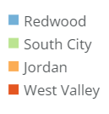
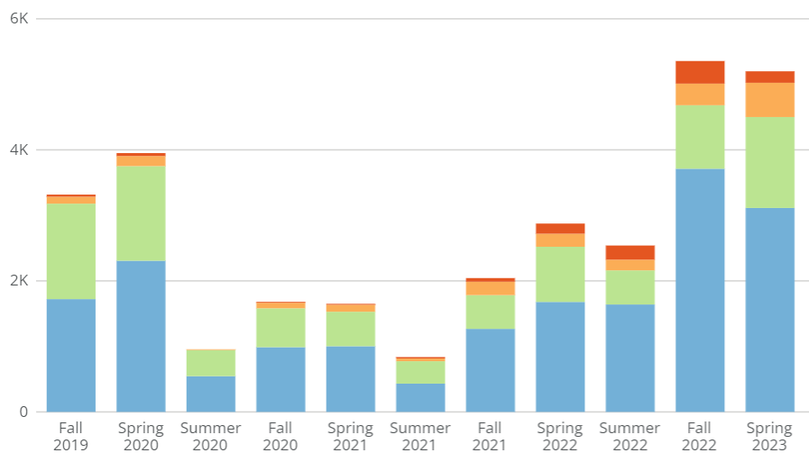
Chart 2: Bruin Pantry demographic changes year 1 to year 3.5
Demographic | Group | Year 1 | % Year 1 | Year 3.5 | % Year 3.5
All | Visits | 8224 |  | 13095
All | Visitors | 1425 |  | 2660
Location | Taylorsville RW | 4580 | 55.6% | 8470 | 64.6%
Location | SCC | 3300 | 40.1% | 2880 | 22%
Location | Jordan | 271 | 3.3% | 1020 | 7.8%
Location | WVC | 71 | 0.9% | 736 | 5.6%
Gender | Female | 790 | 55.4% | 1410 | 53.1%
Gender | Male | 605 | 42.5% | 1080 | 40.7%
Gender | Neutral | 30 | 2.11% | 166 | 6.2%
Ethnicity | African Am. | 87 | 6.1% | 128 | 4.8%
Ethnicity | Asian | 75 | 5.3% | 121 | 4.5%
Ethnicity | Caucasian | 717 | 50.3% | 1080 | 40.7%
Ethnicity | Hispanic/Latinx | 348 | 24.4% | 790 | 29.7%
Ethnicity | Bi/Multiracial | 45 | 3.7% | 67 | 2.5%
Ethnicity | Native American | 22 | 1.5% | 26 | 1%
Ethnicity | Non-Resident | 41 | 2.9% | 85 | 3.2%
Ethnicity | N/A | 66 | 4.5% | 324 | 12.2%
Ethnicity | Pacific Islander | 25 | 1.75% | 37 | 1.4%
First Gen | First Gen | 852 | 59.8% | 2343 | 88.1%
Veteran | Veterans | 47 | 3.3% | 92 | 3.4%
Athletes | Athletes | 13 | 0.01% | 53 | 2%
Employees | Employees | 308 | 21.6% | 437 | 16.4%
Community | Community | 82 | 5.8% | 354 | 13.3%

Graph 2: Bruin Pantry Visitor Ethnicity, Year 1
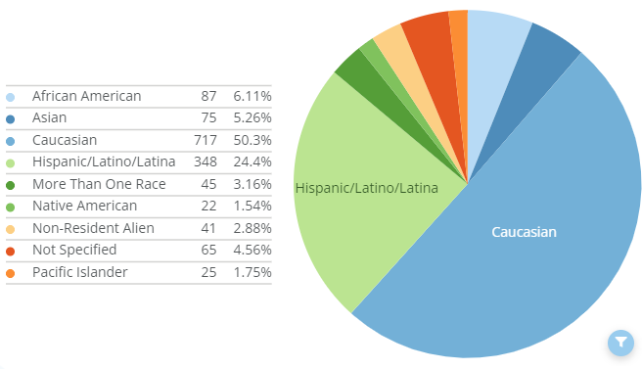

Graph 3: Bruin Pantry Visitor Ethnicity, Year 3.5
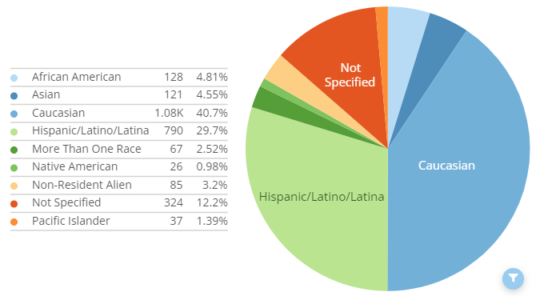

Chart 3: Bruin Pantry visitors terms at SLCC, change from year 1 to year 3
Prior Terms | Year 1 | % Year 1 | Year 3.5 | % Year 3.5
0 previous terms | 232 | 16.3% | 1014 | 38.1%
1 previous term | 73 | 5.1% | 278 | 10.5%
2 previous terms | 113 | 7.9% | 307 | 11.5%
3-5 previous terms | 225 | 15.8% | 498 | 18.7%
6-10 previous terms | 489 | 34.3% | 394 | 14.8%
11+ previous terms | 264 | 18.5% | 169 | 6.4%

